

**JSP 912**

**Human Factors Integration for Defence Systems**

**Part 2: Guidance**

Version 3.0 Mar 2024

# Foreword

This Part 2 provides guidance in accordance with the policy set out in Part 1 of this JSP and is sponsored by Defence Authority for Technical & Quality Assurance. It also provides policy- compliant business practices which should be considered best practice in the absence of any contradicting instruction. However, nothing in this document should discourage the application of sheer common sense.

Capability is not just a function of equipment performance but depends on a combination of interacting elements. Some of the most difficult issues to address lie in the Human Component of Capability. The equipment and systems have to be operated in a demanding and diverse military context in circumstances of fatigue, hunger, stress and even fear. Ultimately, their usability in these demanding environments will determine our operational success. The types of equipment(s)/system(s) we are now specifying and procuring will also shape the roles, responsibilities and career paths of future service personnel whom we recruit and our ability to retain them.

Approaching our Defence needs from a Capability direction, rather than a platform, system or equipment one, will heighten the need for the application of Human Factors Integration to Defence systems. We must set out to deliver solutions that enhance our capability aspirations with a more sophisticated understanding of the role of people in the operation, maintenance and support of our future systems. The challenge is to integrate the people provided by the Armed Forces (including Reservists), with the equipment developed by industry and delivered by the Ministry of Defence, in a way that maximises capability within the real operational environment.

**Stephen Wilcock Director, Engineering & Safety**

**Defence Functional Authority for Technical, Quality & Standardization**

# Preface

## How to use this JSP

1. JSP 912 mandates the application of Human Factors Integration (HFI) in all Defence acquisition projects. It is designed to be used by MOD staff responsible for HFI. This JSP contains the policy and direction for the application of HFI and guidance on the processes involved and best practice to apply HFI in Defence Systems. This JSP will be reviewed every two years.
2. JSP 912 shall be used by MOD staff who are conducting HFI activities in acquisition projects, to ensure that these activities are carried out effectively, efficiently and at appropriate times in a project. It also guides those MOD Staff who provide advice to projects in support roles.
3. The JSP is structured in two parts:
   1. **Part 1 - Directive**, which provides the direction that must be followed in accordance with statute or policy mandated by Defence or on Defence by Central Government.
   2. **Part 2 - Guidance**, which provides the guidance and best practice that will assist the user to comply with the Directive(s) detailed in Part 1. In particular, the guidance summarises HFI processes that are available in the MOD’s Human Factors Integration Management System (HuFIMS)1.

## Coherence with other Policy and Guidance

1. Where this document contains references to policies, publications and other JSPs which are published by other Functions, these Functions have been consulted in the formulation of the policy and guidance detailed in this publication.

|  |  |
| --- | --- |
| **Related JSP** | **Title** |
| JSP 375 | Management of Health and Safety in Defence |
| JSP 536 | Governance of Research Involving Human Participants |
| JSP 815 | Defence Safety Management System |
| JSP 822 | Defence Direction and Guidance for Training and Education |

## Training

1. For training applicable to HFI, consult the following:
   1. Human Factors Integration - Making The Most of People in Systems (available through the Defence Learning Environment): <https://dle.ice.mod.gov.uk/enrol/index.php?id=11908>

1 HuFIMS is hosted on the MOD’s Knowledge in Defence (KiD) website: [https://www.kid.mod.uk/maincontent/business/hufims/index.htm.](https://www.kid.mod.uk/maincontent/business/hufims/index.htm)

* 1. HFI Awareness Training (available on e-solutions2):

<http://mou.isg-r.r.mil.uk/Esolutions/>

## Further Advice and Feedback – Contacts

1. The owner of this JSP is the Defence Functional Authority for Technical, Quality & Standardization, and it is managed by the Defence Equipment & Support (DE&S) Engineering Function HFI Team. For further information or advice on any aspect of this publication or to provide feedback on the content, contact:

|  |  |  |
| --- | --- | --- |
| **Job Title** | **Email** | **Telephone** |
| HFI Team | [DESTECH-EGHFI-Team@mod.gov.uk](mailto:DESTECH-EGHFI-Team@mod.gov.uk) | 07970 508691 |

2 If you do not have access to e-Solutions but wish to attend the Awareness Training please contact: [DESEngSfty-EGITS-HFITeam@mod.gov.uk.](mailto:DESEngSfty-EGITS-HFITeam@mod.gov.uk)

**Contents**

Foreword i

Preface ii

How to use this JSP ii

Coherence with other Policy and Guidance ii

Training ii

Further Advice and Feedback – Contacts iii

1. Introduction to HFI 1

What is HFI? 1

Why Consider the Human Component of Capability? 2

HFI Domains 2

HFI and Systems Engineering 4

HFI and the Defence Lines of Development 5

1. Overview of HFI Process 7

HFI Goals 7

HFI Activities 7

HFI and System Readiness Levels 10

1. HFI Process: Stages and Core Activities 13

General 13

HFI-1.0: User Need Definition 13

HFI-2.0: System Requirements Definition 17

HFI-3.0: Assess Tenders 23

HFI-4.0: Detailed System Design 25

HFI-5.0: Test and Acceptance 34

HFI-6.0: In-Service Feedback 38

1. Tailoring the Process 41

Project Types 41

Modifications to Off-The-Shelf Equipment 42

Tailoring within Defence Acquisition 42

Tailoring the HFI Process 43

1. Roles and Responsibilities 45

Project Team Leader 45

Human Factors Integration Focus 45

Requirements Management 46

Capability Sponsor 46

Capability Integration Working Group 47

HFI Support Function 47

1. HFI Resource Competencies 48

MOD Staff HFI Competencies 48

Solution Provider HFI Competencies 48

Ethical Approval for Research Studies and Trials 48

Conduct and Behaviour 49

1. References 50
2. Acronyms and Abbreviations 52
3. Glossary 55

# Introduction to HFI

## What is HFI?

* 1. Human Factors Integration (HFI) is the process by which the Human Component of Defence Capability is brought together and made to work in Defence systems. It is a systematic process for identifying, tracking and addressing People-Related considerations3, ensuring a balanced development of both technologies and human aspects of capability.
  2. HFI aims to combine People, Processes and Technology into an integrated system capable of safe, effective and efficient performance within the full range of conditions anticipated within the operating environment (see **Figure 1**).

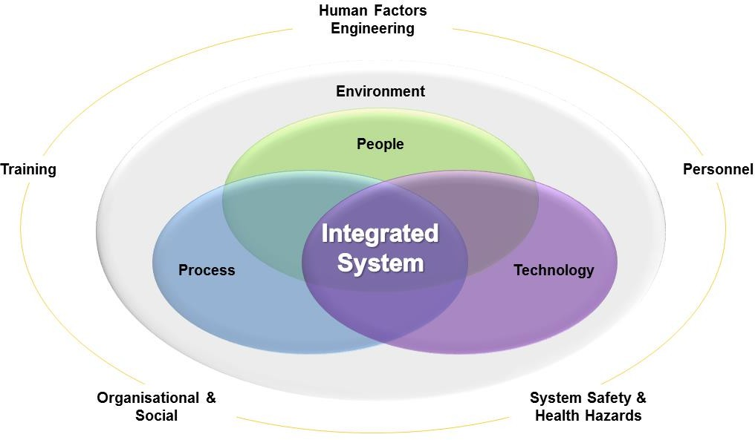

*Figure 1: Components of HFI*

* 1. The People component of HFI refers to the military personnel and civilian support staff who operate, manage, maintain and support the Capability, including the organisations within which they work. The Technology component refers to all of the equipment, hardware, software, information and materiel necessary to deliver the required Capability. These two components are linked by organisational and management Processes that include ways of working, operational tactics, techniques and procedures, and associated training.
  2. In order to achieve the desired Defence Capability, all of the components of HFI must be successfully integrated, considering the Environment in which the Capability will be operated under all conditions of use.
  3. The design and realisation of the Solution should make best use of human capabilities (physical, psychological and social characteristics) and should provide mitigations for

3 HFI Considerations is the collective term for HFI Risks, Assumptions, Issues, Dependencies & Opportunities (RAIDO).

human limitations. The Solution should recognise and provide for human needs and use people in ways that maximise system safety (see [2] and [3]).

## Why Consider the Human Component of Capability?

* 1. Although many Defence Acquisition projects are concerned with the acquisition of technology (i.e. infrastructure, platforms, equipment, hardware, software), even in so-called uninhabited systems, such tangible items must be operated, maintained and supported by people. Thus, whatever their nature, degree of complexity or technological sophistication, systems that provide Defence Capability comprise:
     1. infrastructure, equipment, hardware, software, information and other materials necessary to deliver the required capability (referred to collectively in this document as the ‘Equipment Component’); and
     2. MOD Service personnel and civilian support staff, together with the organisations and structures in which they work, (referred to in this document as the ‘Human Component’).
  2. Failure to consider the Human Component of Capability can have many adverse consequences: increased risk of accidents and incidents; higher training costs; reduced performance and mission effectiveness; breaches in duty of care; scarcity of appropriately skilled personnel; delays to the project schedule and substantial increases in design / redesign costs.
  3. To achieve the required capability, both of these components must work in close combination and harmony. The effectiveness and efficiency of the resulting system, or a constituent part, may depend critically on the Human Component and the adequacy of this combination. Of critical importance is that the People and Equipment Components must be effectively integrated together.
  4. These components are typically linked by operational, organisational and management processes, as illustrated in **Figure 1**. Human-Centred Design is the approach that seeks to accommodate human needs within the design of technological products/systems [4].

## HFI Domains

* 1. HFI involves the identification and trade-off of people-related considerations that could affect capability development and delivery. A framework of five HFI domains is used:
     1. **Personnel** concerns both the numbers of people, (military and civilian), required and available to operate, maintain, sustain and provide training for systems, as well as their physical, cognitive, sensory and behavioural characteristics4. This Domain involves both: understanding the numbers and characteristics of the personnel required by the solution being developed; and informing design decisions to deliver a solution such that: the personnel solution is deliverable and sustainable, and the through life cost of the systems (taking into account both personnel and equipment costs) are optimised. This domain is key to optimising the integration of the People and Equipment DLODs to deliver an effective capability, not just an effective system.

4 Physical characteristics include gender, body size (anthropometry), body shape/composition/morphology, strength, fitness and health. Sensory characteristics include vision (including colour perception), hearing and dexterity. Cognitive characteristics include intelligence, literacy, numeracy and other mental aptitudes, ability to assimilate the training required (for the candidate’s chosen trade) and the ability to work in a team.

Consideration of the numbers of personnel must take account of all emergency and operational conditions of use. Although workforce planning and complementing are primarily the responsibility of Force Generation Authorities, the process of developing the ‘Personnel solution’ requires prior HF-related analyses of skills, qualifications and experience required to be able to operate and maintain the system under consideration.

* + 1. **Training** concerns the training required to develop the knowledge and skills needed by personnel to operate and maintain systems to a specified level of effectiveness under the full range of operating conditions. Effective training builds cohesion and teamwork, and ranges from Train the Trainer (T3) and individual training to collective (team) training, including the conduct of large Task Force exercises that test Command and Control (C2) and the application of doctrine and standard operating procedures. Training must be provided for individual operators, maintainers and support personnel, and for sub-teams and full teams at all levels in the military hierarchy, in order to support the delivery of the operational Capability.
    2. **Human Factors Engineering (HFE)** concerns the comprehensive integration of human physical and cognitive characteristics into system definition, design and development. This includes conducting analyses to support allocation of functions between human and machine and working with engineers to specify, design and evaluate the system solution including aspects such as Human Machine and Computer Interfaces, working environment, accommodation etc. The goal of HFE is to support the delivery of a usable, maintainable and habitable solution that meets the required levels of performance across the anticipated contexts of use.
    3. **System Safety & Health Hazards** concerns operating and maintaining the equipment/system without risk of death or injury or illness (chronic or acute) to people coming into contact with the system (principally its operators and maintainers) or damage to the system. Adverse conditions may occur when the system is functioning in either a normal or an abnormal manner. Every design decision may affect system safety to a greater or lesser degree and may affect the risks to humans from damage, equipment malfunction or operator (human) error. Health hazards can occur in many forms: basic operation of equipment (e.g. repetitive strain injury, muscular strain), exposure to extreme environmental conditions (e.g. cold, heat, noise, vibration), exposure to environmental emissions or materials (e.g. radiation, fumes) or by unhygienic working environment and/or living quarters (e.g. bacterial infection in galleys or washrooms).
    4. **Organisational & Social** involves the process of applying tools and techniques from organisational psychology, management studies, social science, information science and the system of systems approach in order to consider the organisational configuration, social environment and ways of working in a Capability.
  1. The terms ‘Human Factors (HF)’, ‘Human Factors Engineering (HFE)’ and ‘Human Factors Integration (HFI)’ are often confused. ‘Human Factors’ refers to a range of disciplines, which relate to the study of human capabilities, limitations, characteristics and behaviour in the broadest possible sense. It includes the study of human interactions with technologies and social interactions and draws on many scientific disciplines, including ergonomics, psychology (and neuro-psychology), physiology, biology, anthropometry and biomechanics. It provides the knowledge base from which HFE draws. HFE is concerned with the application of this knowledge in the design, development, assessment, fielding, in- service support and disposal of products – equipment, sub-systems, systems and platforms.

In contrast, HFI is a management activity, which includes a systematic process for identifying, tracking and resolving people-related considerations (especially risks and issues), to ensure a balanced development of both technological and human aspects of capability.

* 1. The relative importance of each of the HFI Domains will vary according to the perceived risks identified through the Early Human Factors Analysis (EHFA). The type of procurement employed (e.g. Off The Shelf, Development Item etc.) will contribute to the relative importance of each of the HFI domains, for example, introducing a new Commercial Off The Shelf (COTS) capability to a new organisation may well cause more concerns regarding Training and Social & Organisational domains, than a similar capability procured as a Development Item, where the HFE domain may be more prominant. HFE contributes to the consideration of people-related issues in the other domains, which would normally be led by their respective discipline specialists.
  2. The HFI domains allow for all aspects of human capabilities, limitations and behaviour to be addressed, e.g. from interactions with the physical environment to understanding cultural differences in groups. Importantly the HFI domains are related to each other and should not be considered in isolation. Any decision in one of the domains can easily affect another domain. For example, where the level of automation is increased, there may be a change in required staffing levels, and vice versa.
  3. At the simplest level asking ‘are there concerns relating to this domain?’ can help identify risk(s) to the system, project or programme. This should form a part of the project’s risk management activity. The Human Factors Integration Management System ([HuFIMS](https://www.kid.mod.uk/maincontent/business/hufims/downloads/DLoD_HFprompts.pdf))

[5] is recommended as a source of further information about the HFI domains and the prompts to use when considering them.

## HFI and Systems Engineering

* 1. HFI is an integral part of Systems Engineering (SE), since without the user the system is incomplete and there are few, if any emergent properties. However, many projects/programmes do not consider the user as part of the system and so HFI is required to prompt consideration of human elements.
  2. HFI must be considered throughout the system lifecycle, taking account of both the engineering and support aspects of the solution, e.g. when considering mid-life updates; the procurement of Off-The-Shelf (OTS) products; and when defining and managing an in- service organisation.
  3. The unique characteristics of the Human Component of Capability provide a challenge for systems engineers to manage, hence the requirement for the additional guidance contained in this JSP.
  4. The HFI process reflects agreed SE standards (e.g. International Standards Organisation / International Electrotechnical Commission (ISO/IEC) 15288 [6]) and follows accepted HFI good practice in the management and mitigation of people-related

considerations in projects5. HFI, as part of SE, provides a consistent framework within which projects can systematically address people-related considerations. In addition:

* + 1. process stages are associated with typical project phases, thus providing a mechanism for monitoring performance.
    2. the importance of ‘Learning from Experience’ (LfE) to improve future acquisitions is identified.

## HFI and the Defence Lines of Development

* 1. The Human Component of Capability has an impact upon all Defence Lines of Development (DLODs) and needs to be included in trade-off considerations (see **Table 1**).
  2. The HFI domains provide an additional, complementary viewpoint of the equipment/system under development alongside that provided by the DLODs. Whereas the DLODs help to identify high-level issues at the Programme/Capability level (managed by the Programme Board / Capability Integration Working Group), the HFI domains are of greater utility at the DE&S project level in support of detailed design and development.

|  |  |
| --- | --- |
| **DLOD** | **HFI Considerations** |
| Training | Ensure that personnel are trained to operate the (new or updated) Capability. |
| Ensure that the training is effective. |
| Ensure that the wider issues of training policy have been considered. |
| Equipment | Ensure that the design of the equipment complies with relevant people-related standards. |
| Ensure that all users of the equipment have been identified. |
| Ensure that equipment is fit for its intended purpose. |
| Ensure that the human capability is not reduced by the additional technology capability. |
| Personnel | Ensure that all personnel characteristics that are necessary to ensure the safe operation, maintenance and support of the solution are identified and documented. |
| Ensure that the implications of the new (or updated) capability upon recruitment, selection and retention have been fully considered. |
| Ensure that personnel levels of the new (or updated) capability have been determined and planned for. |
| Information | Ensure that all users involved in the generation, transmission,  receipt, assimilation, manipulation, sharing, storage and maintenance of the information have been identified. |
| Ensure that all users have the information they need for the purposes of the (new or updated) capability. |

5 The term ‘HFI good practice’ means practices that are widely agreed between HFI / HFE professionals to be optimal for their purpose. In some cases, such good practices are enshrined in published standards [e.g. Ref. [6]. The application of an existing good practice does not guarantee its success. The practice must be both appropriate to its application and applied appropriately. To achieve these objectives, professional HFI / HFE input and/or guidance may be required.

|  |  |
| --- | --- |
| Doctrine & Concepts | Ensure that all aspects of information assurance have been dealt with. |
| Ensure that the implications of doctrine for the (new or updated) capability have been fully considered. |
| Understand the importance of doctrine to command. |
| Ensure that the capability matches the reality of operations. |
| Organisation | Ensure that the structure of the organisation is matched to the environment and work or task to be completed. |
| Ensure that the organisational hierarchy has been considered within the overall organisational structure and system operation. |
| Identify the national cultures involved in the organisation and across organisations and identify their differences and similarities. |
| Ensure that organisational processes, procedures and ways of working are considered. |
| Infrastructure | How might changes in accommodation standards and base locations impact on capability? (Duty of care / Personnel expectations) |
| What will be the impact of base relocation on career progression and opportunities? (Personnel expectations) |
| Logistics | Ensure that the capability has the necessary people support. |
| Ensure that the capability has the necessary equipment support. |

*Table 1: HFI Considerations as a Function of DLODs* [7]

# Overview of HFI Process

## HFI Goals

* 1. In all MOD Capability Acquisition projects, the following HFI goals shall be fully pursued to achieve satisfactory outcomes. All HFI activities that are undertaken shall relate to and support one or more of the itemised goals:
     1. ensure that all people-related Risks, Assumptions, Issues, Dependencies and Opportunities (RAIDO) are identified and managed from the very outset of a project, and throughout the rest of its lifecycle.
     2. ensure that all Human Factors Process Requirements (HFPRs) are specified, thereby assuring that HFI processes are properly and adequately undertaken.
     3. ensure that Human Factors User Requirements (HFURs) and Human Factors System Requirements (HFSRs) are specified, thereby assuring that people-related technical aspects of the Solution are properly and sufficiently addressed (based on the identified RAIDO).
     4. ensure that a human-centred design approach is adopted, involving the End Users in system and equipment design and evaluation.
     5. ensure that established Human Factors principles, accepted best practice, and suitable methods, tools, techniques and data are used.
     6. ensure that the HFI programme is designed to align and integrate effectively with the project lifecycle.
     7. ensure that people-related considerations of the Solution undergo formal scrutiny, assessment and acceptance.
  2. All HFI activities that are undertaken should relate to and support one or more of the itemised goals. When each of the goals has been satisfactorily addressed, a project may claim that HFI has been satisfactorily achieved.

## HFI Activities

* 1. The HFI process consists of a series of people-related activities that are conducted throughout the development of the Solution. The high-level activities, as illustrated in **Figure****3**, are:
     1. User Need Definition.
     2. System Requirements Definition.
     3. Assess Tenders.
     4. Detailed System Design.
     5. Test and Acceptance.
     6. In-Service Feedback.
  2. The HFI activities are applicable to all types of Capability Acquisition projects based on a generic system lifecycle model that encompasses Concept, Assessment, Demonstration, Manufacture, In-Service, and Disposal (CADMID), and other development stages (e.g. ISO/IEC 15288 [6]). However, an exact alignment with CADMID is not possible due to the slight differences for categories and classes of project.
  3. The ‘Outline Business Case (OBC)’ is the point when the Capability Sponsor and Delivery Team seek approval for their Concept of Analysis, which sets out the approach and criteria for assessing options in the Assessment Phase. The ‘Full Business Case (FBC)’ occurs after the Assessment work has been undertaken and is the major decision point at which the Solution, supported by mature requirements specifications, i.e. the User Requirements Document (URD) and System Requirements Document (SRD), is approved.
  4. Some HFI activities can only be carried out when the project has reached a certain stage of development. Thus, the timing and duration of HFI activities must be synchronised with other project activities, primarily to ensure the necessary information flow between Stakeholders and between the Acquirer and the Solution Provider.
  5. The scope, extent, depth, complexity and thoroughness of all HFI activities to be undertaken, should be determined by (or tailored to) consideration of the risks to the required project outcomes. These are typically measured in terms of capability goals, objectives, cost, time, system performance, system safety and system usability.
  6. Through the course of the life cycle the maturity of HFI will be assured from an engineering prespective using the Guide to Engineering Activities and Reviews ([GEAR](https://moodportal.ahe.r.mil.uk/GEAR/Login.aspx?ReturnUrl=%2fGEAR%2fController.aspx%3felementId%3d70621008811948049C2C6BFBC37ADAF1%26elementType%3dProcess%26modelMasterId%3d&ReturnUrlFail=%7e%2fNoPermission.aspx)) and the System Readiness Levels ([SRLs](https://www.kid.mod.uk/maincontent/business/techman/content/srl_whatarethey.htm?zoom_highlight)), and from a support perspective using the Support Solutions Envelope ([SSE](https://www.kid.mod.uk/maincontent/business/sse_21/content/sse_about.htm?zoom_highlight=SSE)) Support Solutions Development Tool (SSDT). These assurance points are illustrated below along with the HFI process in **Figure 2**.

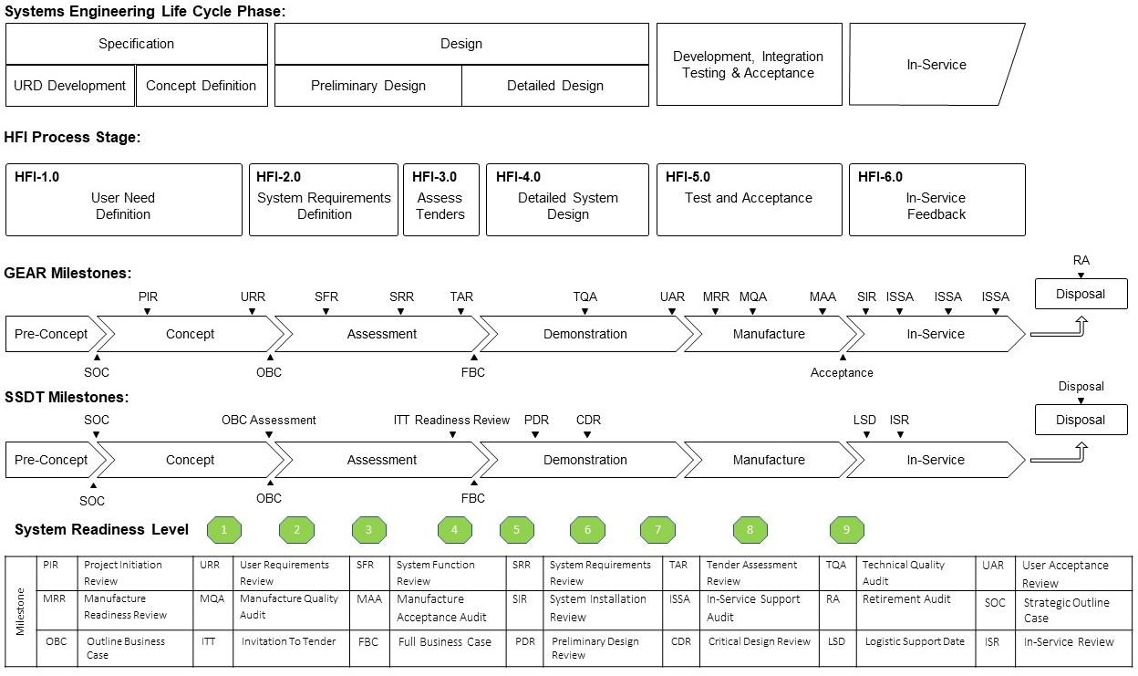

*Figure 2: HFI Process*

## HFI and System Readiness Levels

* 1. As part of the MOD’s approach to Technology Management, System Readiness Levels (SRLs) were developed as a project management tool to capture evidence and assess and communicate system maturity in a consistent manner to stakeholders. Evidence of SRL achievement is used for project assurance at key decisions points.
  2. The SRLs define a set of nine maturity steps from the User Requirements (SRL 1) to Proven System (SRL 9) that map onto the SE and CADMID lifecycles (see **Figure 3**). Project maturity at each of the nine steps is assessed across a set of nine SE disciplines or ‘drivers’ such as Training, Software, and Information Systems, including HFI6.

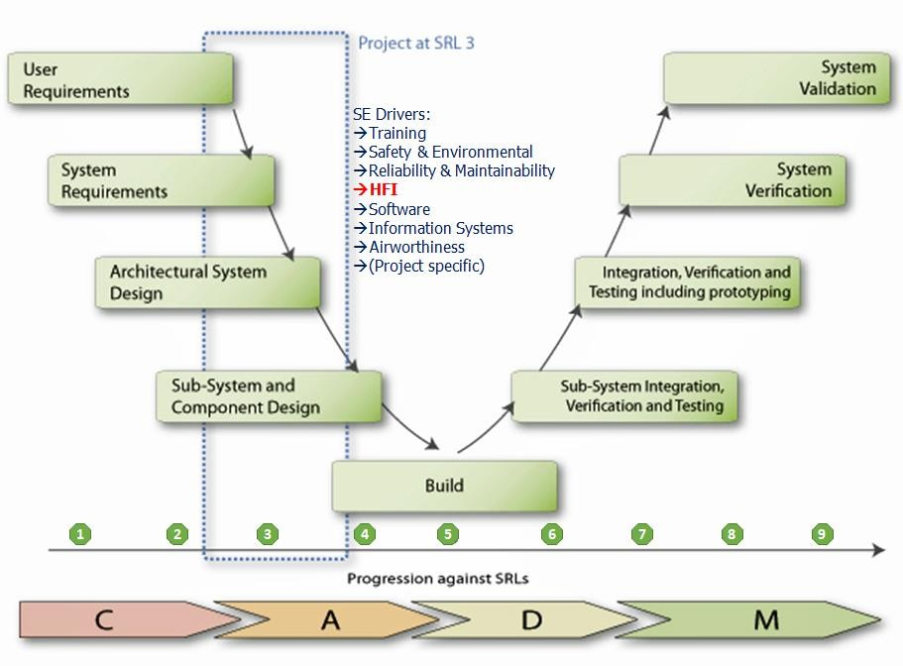

*Figure 3: Systems Engineering Lifecycle and SRLs*

* 1. The SRL (HFI) information, reproduced from a simple self-assessment tool available on the Knowledge in Defence (KiD) website7, is shown in **Table 2**.

6 One of the nine drivers is ‘project specific’, i.e. considerations at the discretion of the Project Team (PT).

7 [https://www.kid.mod.uk/maincontent/business/techman/content/srl_whatarethey.htm.](https://www.kid.mod.uk/maincontent/business/techman/content/srl_whatarethey.htm)

|  |  |  |
| --- | --- | --- |
| **SRL (HFI)** | **Goal** | **Rationale** |
| 1 | The HF issues implicit within the URD have been understood. | At this stage of a project’s maturity, HFI must begin with an analysis of Human issues related to the acquisition of the proposed capability, and an assessment of the associated risks and requirements. The HFI objective during this level is to ensure that the stage outputs submitted at OBC take account of any people-related issues that could seriously affect the ability to meet the project’s objectives. This applies to all outputs including: Requirements (URD, draft SRD and ITT/ITN SoR/SOW), plans (costed plan for Assessment, Through Life Management Plan (TLMP) and any contribution to other specialist plans such as Safety and  ILS) and cost effectiveness assessment (impact of Human performance and Human costs). |
| 2 | Clear definition of the Human roles within the system. | At this level, more detailed work is undertaken to understand, quantify and begin to reduce the HFI risks identified during the earlier phase. This will involve exploring major issues, such as reductions in the  numbers of personnel available, job design, workload, performance shortfalls and safety management. |
| 3 | The requirements to support the Human Component of the system have been clearly  defined. | At this stage of a project’s maturity, a comprehensive understanding of the capability is used to develop Human Factors system requirements. |
| 4 | HFI input has been provided to the SRD and responsibilities for these aligned  with other disciplines. | At this stage of a project’s maturity, a comprehensive understanding of the capability is used to develop Human Factors system requirements that are aligned with other project disciplines. |
| 5 | Conduct and test initial evaluation of HFI. | At this stage of a project’s maturity, specifications are refined to ensure robust HFI content, with clear human performance targets. Contractor offerings are evaluated to predict operability, maintainability and supportability of the eventual Solutions. HFI concerns must be included in the down selection criteria for equipment characteristics, associated services, overall integration, and the process offered to develop and deliver the Solution and reduce risks. After down selection, contractor HFI effort becomes more closely coupled to MOD activities, with MOD providing user expertise to  support the contractor’s HFI team. |
| 6 | Verify sub- systems within representative environment. | At this stage of a project’s maturity, key sub-systems are integrated with realistic supporting elements so that sub- systems can be tested in a simulated operational (laboratory) environment. |

|  |  |  |
| --- | --- | --- |
| **SRL (HFI)** | **Goal** | **Rationale** |
| 7 | Demonstration of system prototype within integration environment. | At this stage of a project’s maturity, a representative prototype system should be demonstrated (with all major sub-systems integrated and operating) in a high-  fidelity simulated environment such as a vehicle integration test rig. |
| 8 | Achievement and acceptance of the human related aspects of design and function. | At this stage of a project’s maturity, the final pre- production system should be demonstrated in a representative target platform. |
| 9 | Any future issues relating to HFI in completing the TLMP can be monitored and managed effectively by the project. | At this stage of a project’s maturity, declaration of the In- Service Date (ISD) follows demonstration of effective integration of the equipment with the Human Component (personnel, procedures, support, and training regimes) under operational conditions. While in- service, HFI evaluation helps to identify any human related performance shortfalls or failures of Human-  equipment integration and allows for the potential of in- service design changes/upgrade. |

*Table 2: System Readiness Levels (HFI)*

# HFI Process: Stages and Core Activities

## General

* 1. The HFI process consists of six high-level stages:
     1. HFI-1.0: User Need Definition.
     2. HFI-2.0: System Requirements Definition.
     3. HFI-3.0: Assess Tenders.
     4. HFI-4.0: Detailed System Design.
     5. HFI-5.0: Test and Acceptance.
     6. HFI-6.0: In-Service Feedback.
  2. Each of these stages consists of a number of core activities that have defined inputs and outputs. These processes are described below8. The owning MOD agency responsible for a core activity (e.g. Front-Line Command (FLC) / Capability (Cap), DE&S) might not necessarily undertake the actual work. Instead, an organisation with a relevant Suitably Qualified and Experienced Person (SQEP) might be contracted to undertake the work (e.g. DE&S, Dstl or other commercial entity).
  3. Further detailed guidance on each process stage and core activity is available in HuFIMS [5], including tailoring guidance and user checklists for each process core activity.

## HFI-1.0: User Need Definition

* 1. The primary goal of the User Need Definition stage is to ensure that appropriate human considerations are included in the User Requirements and that sufficient information is provided to the Acquirer to support the development of HFSRs. This stage shall be addressed during the Pre-Concept and Concept Phases in support of the development of the Outline Business Case (OBC). HFI-1.0 aligns best with the Programme Identification activities in the Capability Management process, which occur immediately following the issue of a draft Programme Mandate. At this stage in the Capability Management process, a specific capability need has been identified, funding for a defined capability option has been approved and a Senior Responsible Owner (SRO) has been appointed. Desk Officers are then tasked with the preparation of Key User Requirements and the initial Concept of Employment (CONEMP).
  2. The User Need Definition stage (HFI-1.0) consists of 7 core activities as shown in

### Figure 4.

8 HFI in the Disposal phase (see **Figure 2**) has not been identified as a unique HFI process, as its contribution to Disposal should generally be considered as part of the detailed design activities. Where a capability has changed significantly through life, or legislation concerning the disposal of particular substances has changed significantly, there may be a need to establish a dedicated disposal contract.

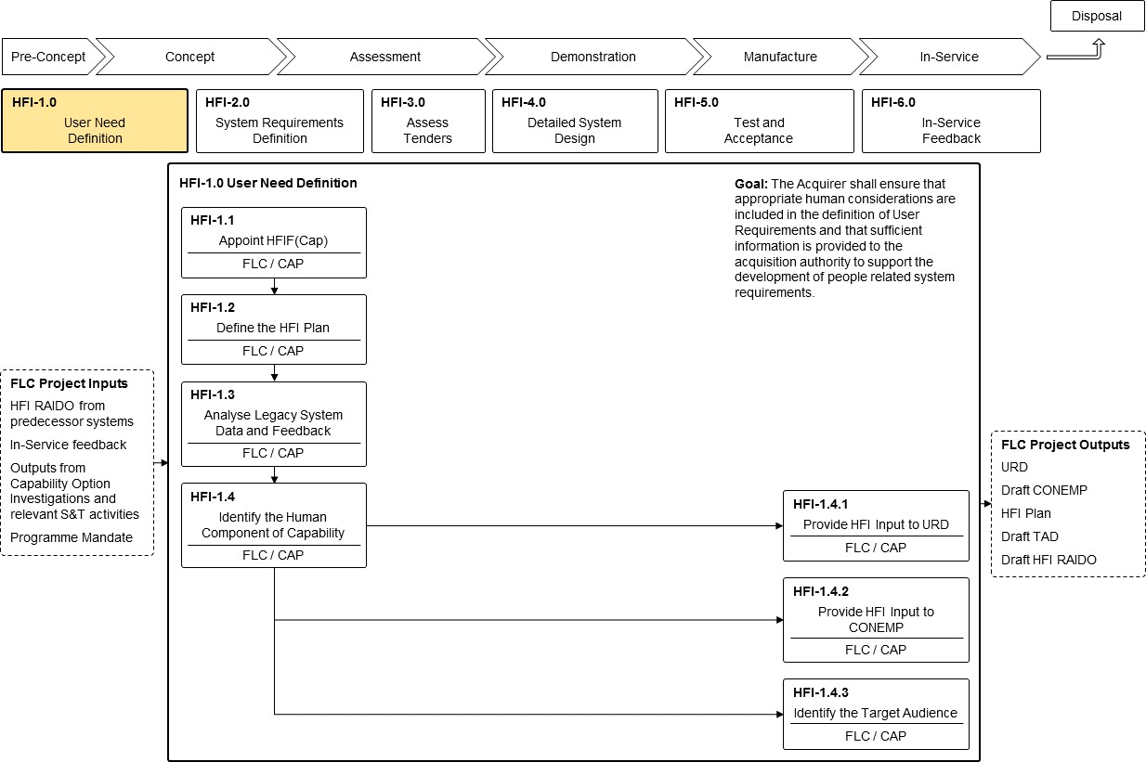

*Figure 4: User Need Definition (HFI-1.0)*

### HFI-1.1: Appoint HFI Focus (Cap)

* 1. The starting point for the HFI process shall be the identification of a person to act as the ‘HFI Focus’ within the FLC/Cap Community, known hereafter as HFI Focus (Capability)9. The HFIF(Cap) is responsible for managing FLC activities associated with defining the people-related User requirements for the capability (see also Section 5 (Roles and Responsibilities - Human Factors Integration Focus). The HFIF(Cap) is unlikely to be a dedicated or full time resource, rather the role is likely to form part of the FLC Capability Development Desk Officer role as the Capability Desk Officer will have to consider HFI during the development and assessment of Capability Options, selection of preferred option and subsequent development of the URD and CONEMP.
  2. The HFIF(Cap) shall have, as a minimum, an ‘Awareness’ level of HFI knowledge (ideally Practitioner) as defined by the Human Factors Integration Functional Competence Framework [8]. The HFIF(Cap) may need support from a SQEP from other sources, either internal to MOD (e.g. DE&S’s Internal Technical Support (ITS) HFI Team or Dstl) or external to MOD (e.g. the Engineering Delivery Partner (EDP)).
  3. The HFIF(Cap) shall be responsible for ensuring the completion of activities HFI-1.2 - HFI-1.4.

9 Abbreviated to HFIF(Cap).

### HFI-1.2: Define The HFI Plan

* 1. The first issue of the MOD HFI Plan shall describe the project approach to HFI with particular emphasis on the pre-contract Front Line Command (FLC) activities associated with defining the people-related User requirements and measures of effectiveness for the capability. The HFI Plan should identify the HFI Stakeholders across all Defence Lines of Development (DLODs) and describe how they will be engaged in the development of the URD and CONEMP. Consideration should be given to each of the DLODs to identify potential HFI issues and risks associated with the required Capability and the activities that will be required to address them.
  2. Every project shall develop and implement a HFI Plan. The scale and complexity of the Capability being procured will determine the level of detail required in the plan and the level of specialist resource required.
  3. The HFI Plan shall conform with the requirements of [GEAR](https://moodportal.ahe.r.mil.uk/GEAR/Controller.aspx?elementId=E26C1C21B20143B097CF7C3D600492F3&elementType=Processes&modelMasterId) [9] and the HFI Product Description ([HFI-PD01](https://www.kid.mod.uk/maincontent/business/hufims/downloads/pd/20220628-HFI-PD01_Capability_HFIP_O.pdf) available in HuFIMS [5]). Any Tailoring of the HFI Process shall be agreed with the Defence Authority (HFI Policy Team).

### HFI-1.3: Analyse Legacy System Data & Feedback

* 1. Analysis of legacy and comparable systems provides a valuable information source for the procurement of new capabilities. Analysis of existing in-service, predecessor or analogous equipment with similar characteristics to the proposed Solution may reveal HFI considerations that must be addressed during the acquisition programme.
  2. Examples of the sources of relevant information, including safety and accident / near- miss databases, are:
     1. in-service feedback from Front Line Commands.
     2. HFI RAIDO Registers from predecessor systems (if available).
     3. pan-Defence lessons learned such as the Defence Lessons Identified Management System (DLIMS) [10], the Air Systems Information Management System (ASIMS) [11] or the Navy Lessons Process10.
  3. It is important to identify not only problems with the predecessor equipment/ system, but also its good features, which can be carried forward to potentially reduce the training burden at the outset.
  4. This data capture exercise forms the HFI baseline dataset that forms the basis of an Early Comparability Analysis (ECA), which might be revisited as part of the Early Human Factors Analysis (EHFA) activities in HFI-2.0 (System Requirements Definition), or after a significant change to the programme or system concept. This will normally entail the generation of a HFI RAIDO Register. Further guidance on the EHFA process and development of the RAIDO (including exemplar templates) can be found in HuFIMS [5].

10 Information relating to DLIMS is available from the Defence Gateway: Army Knowledge Exchange (AKX). Information relating to the Navy Lessons Process, which is based on DLIMS, is available from the Defence Gateway Royal Navy Portal [13].

### HFI-1.4: Identify The Human Component of Capability

* 1. The HFIF(Cap) should work with the Head of Capability (HoC) to ensure that the Human Component of Capability is identified and understood. The HFIF(Cap) must generate and/or inform requirements where people either are or might be involved with the capability being procured, even if the Human contribution to the capability itself is subsumed within statements that are more general. This will help avoid later difficulties when the more specific System Requirements Document (SRD) is being derived from the URD.
  2. Addressing HF for a project can be challenging; requirements related to human performance can be difficult to specify, with measurable criteria difficult to define. Co- ordinating contributions from the many stakeholders with an interest in Human issues can be complicated by the organisational boundaries involved. The Capability Coherence Authority or Joint Capability Board might provide useful input of ‘pan-Project Team’ issues and requirements.

### HFI-1.4.1: Provide HFI Input to URD

* 1. The URD specifies the required military capability, which in almost all cases will be provided by some combination of equipment, personnel, training, doctrine, support, etc. The URD plays a pivotal role in the whole acquisition project, since it drives all later requirements and plans. It is extremely rare for people not to form part of a capability. It is therefore important to provide appropriate high level ‘hooks’ in the URD to which more specific HFSRs in the SRD can be traced.
  2. The URD is owned by the Front-Line Command/Capability branch. In many cases the final document will be prepared with assistance from the Acquirer (PT) and representatives covering other DLODs. Some of these stakeholders may subsequently be members of the CIWG. However, the CIWG may not have officially formed at this early point in the lifecycle.
  3. Defence Standard 00-251 [2] provides a set of candidate HF User Requirements (HFURs) for use by Front-Line Commands when populating the URD. The HFURs describe the needs of people to contribute to the delivery of the Capability. The HFURs may not all apply in their entirety to every project, but they should be considered by the MOD for their relevance at the capability level. The HFURs are intentionally generic in order that they may apply to a range of different capability projects. The provision of these HFURs does not preclude the development of alternative, capability-specific HF requirements within the URD where there is sufficient HF knowledge to support their development. They are intended as candidate requirements to support the development of the URD as a practical means of proceeding.
  4. The HFIF(Cap) shall ensure that the URD adequately covers HFI. This should be achieved by either:
     1. including the HFURs defined in Defence Standard 00-251 (ideally, tailored to the specific context of the capability); or
     2. ensuring that all of the HFURs defined in Defence Standard 00-251 are adequately covered by other User Requirements in the URD as appropriate to the project context.
  5. For further guidance on the development of HFURs consult the [HFI Process Leaflets](https://www.kid.mod.uk/maincontent/business/hufims/downloads/process/hfi141.pdf) within HuFIMS11.

### HFI-1.4.2: Provide HFI Input to CONEMP

* 1. The Concept of Employment (CONEMP) describes how a new capability will be employed and is primarily written to allow the requirements for that capability to be refined prior to FBC approval. It provides a key context document in support of the URD, to enable the derivation of the detailed System Requirements, by providing information concerning the anticipated operational use of the system. The CONEMP provides an overview of how the capability will fit into the larger defence system and likely envisaged modes of operation and mission durations.
  2. The HFIF(Cap) shall contribute to the development of the CONEMP to ensure that it contains appropriate consideration of the Human Component and any implied HFURs. The HFIF(Cap) should also identify any potential issues or concerns arising from an HFI perspective within the developing CONEMP (e.g. potential conflicts between the URD and the CONEMP).
  3. The Concept of Use (CONUSE) describes the way in which a specified capability is to be employed in a range of activities, operations or scenarios. It is derived from the CONEMP for FBC in order to inform and support the SRD as a capability approaches its In-Service Date (ISD). It will remain in existence throughout the life of a platform or equipment. The CONUSE should be reviewed and updated regularly, with typical triggers being a major change in doctrine or policy, or the agreement of new requirements.

### HFI-1.4.3: Identify the Target Audience

* 1. A common understanding of who will operate, maintain and support the equipment / system is important to ensure that the delivered solution is compatible with the capabilities and limitations of those people. At this early stage, the development of the Target Audience Description may be limited to identifying who the users, maintainers, trainers etc. are (or will be) to support the development of the URD, SRD and CONEMP. This can be used to identify risks and issues in terms of the personnel required to operate, maintain, train and support the solution. The Target Audience Description (TAD) will be matured in stage 2 of the HFI Process (activity [HFI-2.4](https://www.kid.mod.uk/maincontent/business/hufims/downloads/process/hfi24.pdf)) where pertinent details of the Target Audience are defined.
  2. The HFIF(Cap) should identify where the Users for the system will come from and liaise with the necessary personnel departments to ensure that the personnel required by the system can be provided within the timeframes envisaged for the delivery of the capability.
  3. A HFI Product Description ([HFI-PD06](https://www.kid.mod.uk/maincontent/business/hufims/downloads/pd/20190604-HFI-PD06_TAD.pdf)), and further guidance for production of the TAD is available in HuFIMS12 [5].

## HFI-2.0: System Requirements Definition

* 1. The primary goal of the System Requirements Definition stage is to ensure that appropriate HFPRs and HFSRs are developed and incorporated into the Invitation to Tender/Invitation to Negotiate (ITT/ ITN) documentation, and that potential Solution Providers are provided with the necessary information to enable them to respond effectively.

11 Select: Human Factors Integration / HFI Process / Download all HFI Process Leaflets / HFI-1.4.1 Provide HFI Input to User Requirement Document (URD).

12 Select: Resources / HFI Process Products / HFI-PD06.

This process shall be completed during the latter stages of the Concept Phase and throughout the Assessment Phase in support of the development of the SRD, Statement of Requirement (SOR) and ITT/ ITN materials. The System Requirements Definition stage (HFI-2.0) consists of 10 core activities as shown in **Figure 5**.

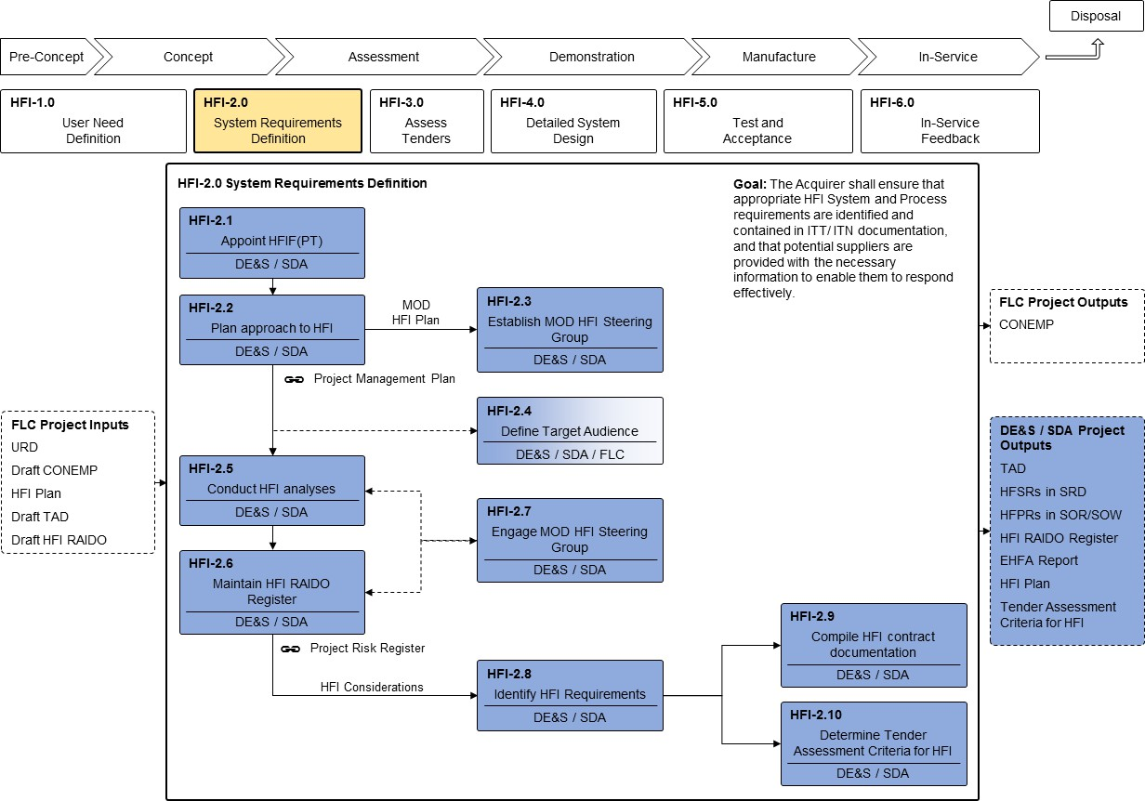

*Figure 5: HFI-2.0 System Requirements Definition*

### HFI-2.1: Appoint HFI Focus (Project Team)

* 1. The first HFI activity is to identify and appoint an individual to be responsible for HFI within the PT/DT. This person will become the HFI Focus for the PT/DT, hereafter known as HFIF(PT). Since much HFI activity involves influencing other stakeholders whose responsibility HFI overlaps, the HFIF(PT) should be a good ‘influencer’.
  2. The HFIF(PT) should be a SQEP with an ‘Awareness’ level of HFI competence as a minimum, although ‘Practitioner’ level is preferred (see also Section 6). In the case where this is impracticable, the appointed individual will need support from a SQEP from other sources, either internal to MOD (e.g. DE&S’s Internal Technical Support (ITS) HFI Team) or contracted support external to the MOD.

### HFI-2.2: Plan Approach to HFI

* 1. The HFIF(PT) shall produce a HFI Plan for the project, with particular emphasis on the pre-contract MOD activities associated with defining the Human Factors Requirements for the system/capability (see HFI-2.8), devlopment of the contract with the Solution Provider and engagement of HFI stakeholders across the project team. The HFIF(PT) shall ensure that the HFI Plan complies with the HFI Product Description ([HFI-PD02](https://www.kid.mod.uk/maincontent/business/hufims/downloads/pd/20190821-HFI-PD02_HFIP-MOD.pdf)) and satisfies the

GEAR quality criteria. Any tailoring of the HFI process activities shall be agreed with the HFI Policy Team. This will help to ensure that HFI adequately addresses Support Solutions Envelope (SSE) Core Development Area 2 (CDA 2)13 from a Support perspective and GEAR from an Engineering perspective.

* 1. The HFIF(PT) shall ensure that the HFI activities identified within the HFI Plan are aligned with timelines of the project and the FLC HFI Plan (see HFI-1.2). The HFIF(PT) shall liaise with other Systems Engineering stakeholders to ensure that the HFI effort is integrated with the PT’s activities as a whole.
  2. It should be noted that the HFI Plan developed by the PT will not be the same as the HFI Plan developed by the Solution Provider, although there will be elements common to both. Furthermore, the HFIF(PT) may need to review and update the HFI Plan prepared earlier (see HFI-1.2) to reflect the actual PT context (resources, timescales, etc.). Further information relating to the HFI Plan is contained within the HuFIMS [HFI Process Leaflets](https://www.kid.mod.uk/maincontent/business/hufims/content/hufims_hfiprocdown.htm)14 and HFI Plan Product Description ([HFI-PD02](https://www.kid.mod.uk/maincontent/business/hufims/content/hufims_hfguide_product.htm))15.

### HFI-2.3: Establish MOD HFI Steering Group

* 1. Prior to contract award, the HFIF(PT) shall liaise with other MOD and FLC stakeholders to develop HFI inputs to requirements documents and other tender materials. Establishing a MOD HFI Steering Group prior to contract award can provide a useful forum for the HFIF(PT), assisting in tasks such as Early Human Factors Analysis, Early Comparability Analysis and development of HFPRs and HFSRs.
  2. The HFIF(PT) shall seek key representation from FLC Stakeholders, including the Requirements Manager and representatives of the anticipated user, maintainer and trainer population. Further attendance may be sought from other members of the PT as required, particularly where trades or risk mitigation activities may need to be discussed between different SE and HFI domains.
  3. The size, complexity and level of HFI risk presented by a programme will determine the size, membership and scope of the MOD HFI Steering Group. Recommended Terms of Reference for the MOD HFI Steering Group and an outline agenda are available on HuFIMS ([HFI-TR01](https://www.kid.mod.uk/maincontent/business/hufims/downloads/pd/20190918-HFI-TR01_TOR-HFISG.pdf)).

### HFI-2.4: Define the Target Audience

* 1. The HFIF(PT) shall work with the HFIF(Cap) to define the Target Audience, building on the draft Target Audience Description developed earlier (see HFI-1.4.3). The TAD is a detailed description of the people who will operate, support, sustain and maintain the Solution. Data relating to the physical, psychological and sociological characteristics of individual users and groups of users will be included in the TAD; as will data relating to the organisations to which users belong. Selection criteria, career paths and training requirements are also included. Further information relating to the TAD is contained within the HFI Process Leaflets and Target Audience Description Product Description ([HFI-PD06](https://www.kid.mod.uk/maincontent/business/hufims/downloads/pd/20190604-HFI-PD06_TAD.pdf)) available in HuFIMS16.

13 CDA 2 (Human Factors Integration) replaced Governing Policy 2.9 (GP2.9).

14 Select: Human Factors Integration / HFI Process / Download all HFI Process Leaflets.

15 Select: Resources / HFI Process Products / HFI-PD02.

16 Select: Resources / HFI Process Products / HFI-PD06.

* 1. The TAD will inform and be informed by the HFI analyses (see HFI-2.5). For example, the TAD will provide information concerning the available personnel, while the HFI analyses may identify additional roles and personnel requirements that had not previously been considered.

### HFI-2.5: Conduct HFI Analyses

* 1. The breadth and depth of HFI analyses conducted will be driven by the size and complexity of the programme as well as the particular people-related risks. As a minimum, all programmes shall conduct an EHFA at some level of detail. Further analysis activities may be required in accordance with the risks identified and the supporting material required for the ITT/ITN.
  2. The EHFA (and associated ECA) is central to the HFI process, providing the risk-based rationale that underpins most of the subsequent investment in HFI for the project. Early in the Concept Phase the HFIF(PT) shall ensure that an EHFA is conducted involving appropriate stakeholders (both within and outside of the PT). Workshops are an effective way to conduct the EHFA, with the HFI Baseline dataset forming an input (see HFI-1.3 for further details). Further information relating to the EHFA is available within HuFIMS, including a Technical Guide ([TG11.1](https://www.kid.mod.uk/maincontent/business/hufims/content/hufims_hfguide.htm)) for the conduct of EHFA, the HFI RAIDO Register tool ([HFI-PD04b](https://www.kid.mod.uk/maincontent/business/hufims/downloads/pd/20161215-EHFA_Tool_Template_Issue_1_2_3.xlsm))17, and product descriptions for the EHFA Report ([HFI-PD05](https://www.kid.mod.uk/maincontent/business/hufims/downloads/pd/20190516-HFI-PD05_EHFA_Report-v1-O.pdf)) and HFI RAIDO Register ([HFI-PD04](https://www.kid.mod.uk/maincontent/business/hufims/downloads/pd/20190821-HFI-PD04_HFI_RAIDO_Register.pdf)). A template for the EHFA Report is also available in [GEAR](https://moodportal.ahe.r.mil.uk/GEAR/Controller.aspx?elementId=C31B3C78DE0744E08BB4B4540B0DB914&elementType=Processes&modelMasterId).
  3. The HFI domains and the DLODs provide useful frameworks and prompts, to assist workshop attendees in identifying potential HFI considerations. Once risks have been captured, they should be evaluated and assessed for probability and impact and potential response plans formulated.
  4. The conduct of the EHFA may identify additional analyses as part of the action plan to address the identified HFI considerations. These additional analysis activities may be required in order to define requirements for the new system and may include activities such as:
     1. task analysis / task synthesis and use case / system modelling (understanding how tasks are performed on existing/predecessor systems and 'projecting' how they might be performed on the new system, capturing the role of the human in the system and the allocation of functions between individuals and other elements of the system).
     2. human performance modelling and prediction (understanding factors such as workload, human error, situation awareness and how they may contribute to total system performance).
     3. initial training needs analysis, considering factors such as training fidelity analysis (particularly for simulation projects).
     4. personnel analysis (e.g. setting the maximum complement for ships and submarines, and understanding the roles that the human component of capability will perform).
     5. environmental analysis (e.g. determining the habitability requirements based on operating environments, clothing and equipment ensembles and levels of work).

17 An Excel tool used for gathering and Managing HFI Considerations.

* + 1. workspace analysis (e.g. developing access and space requirements based on the percentile ranges and equipment configurations of the specified user population).

### HFI-2.6: Maintain HFI RAIDO Register

* 1. The HFI Risks, Assumptions, Issues, Dependencies and Opportunities (RAIDO) Register provides a management tool to record and track HFI considerations, through the course of a programme.
  2. The HFIF(PT) shall maintain the HFI RAIDO Register. The Register should be generated early in the Assessment Phase (if it is not already available from the Concept Phase activities). During this stage it is the HFIF(PT)’s responsibility to ensure that the HFI RAIDO Register is up to date and is regularly reviewed with HFI stakeholders through the HFI Steering Group18.
  3. The HFI RAIDO Register should be produced in a standardised template and each entry should include at least a unique number, title, brief description, priority, source, owner, mitigation strategy and status. An HFI [RAIDO Register template](https://www.kid.mod.uk/maincontent/business/hufims/downloads/pd/20161215-EHFA_Tool_Template_Issue_1_2_3.xlsm) and [User Guide](https://www.kid.mod.uk/maincontent/business/hufims/downloads/pd/20191108-EHFA_Tool_User_Guide_Issue_2-2.pdf) are available in HuFIMS19.

### HFI-2.7: Engage MOD HFI Steering Group

* 1. The HFIF(PT) shall be responsible for convening the MOD HFI Steering Group with support from the PT Leader and FLCs. The HFIF(PT) shall ensure attendance from the DE&S project team as well as appropriate FLC representation, as required by the Steering Group agenda.
  2. The HFIF(PT) is responsible for chairing the Steering Group meeting, setting the agenda and managing attendance in line with the topics for discussion at the meeting.
  3. Recommended Terms of Reference for the MOD HFI Steering Group and an outline agenda are available in HuFIMS ([HFI-TR01](https://www.kid.mod.uk/maincontent/business/hufims/downloads/pd/20190918-HFI-TR01_TOR-HFISG.pdf))20.
  4. The HFIF(PT) should utilise the Steering Group to engage with the DLOD owners, to ensure that all of the capability DLODs are sufficiently represented at Steering Group meetings and integrated within the HFI process.

### HFI-2.8: Identify Human Factors Integration Requirements

* 1. There are three types of HFI requirement:
     1. **Human Factors User Requirement (HFUR)**. These requirements, identified by the HFIF(Cap) during the User Need Definition stage (see HFI-1.4.1), are intended for inclusion in the URD. Defence Standard 00-251 contains a set of generic HFURs from which more specific HFURs can be derived.
     2. **Human Factors System Requirement (HFSR)**. These requirements are intended for inclusion in the SRD. Defence Standard 00-251 contains a set of generic HFSRs (derived from the HFURs) from which more specific HFSRs should be derived together with appropriate measures of performance. The HFSRs provide a lower level

18 Responsibility for the generation/maintenance of the HFI RAIDO Register transitions from the HFIF(Cap) to the HFIF(PT) at the end of the Concept Phase.

19 Select: Resources / HFI Process Products / HFI-PD04 & UG-01 respectively.

20 Select: Resources / HFI Process Products / HFI-TR01.

of detail for the characteristics that an overall technical and personnel solution must embody. A suite of Technical Guides (available within HuFIMS) supports the development of these detailed requirements and measures of performance. The HFIF(PT) shall ensure that for each identified HFSR, the following attributes are identified and agreed between stakeholders:

* + - 1. ownership.
      2. threshold and objective measures of performance.
      3. priority (including tradability).
      4. tailoring.
      5. proposed means of demonstrating compliance.
    1. **Human Factors Process Requirement (HFPR)**. These requirements are intended to be invoked by the contract agreed with the Solution Provider. Defence Standard 00-251 [2] provides a tailorable selection of generic HFPRs for inclusion within the contractual Statement of Requirement (SOR)). The HFPRs should be applicable to most if not all acquisitions but may require some tailoring in accordance with the capability and type of acquisition. The HFIF(PT) shall be responsible for the selection of HFPRs and justify any exclusions from the generic requirements set. The HFIF(PT) shall seek agreement from the HFI Policy Team for any derogations from the HFPRs defined in the Defence Standard 00-251.
  1. Ensuring that HF requirements are Specific, Measurable, Achievable, Realistic and Time-bounded (SMART) will reduce acceptance issues later in the acquisition process. The HFSRs detailed in Defence Standard 00-251 have been designed to be applicable across all types of projects and for all domains. For this reason, requirements will not be SMART until they have been reviewed against the needs of a given system and modified as required by the HFIF(PT).
  2. For further information about HF requirements, consult Defence Standard 00-251 and HuFIMS.

### HFI-2.9: Compile HFI Contract Documentation

* 1. The HFIF(PT), shall support the project contract management staff, with the compilation of the HFI elements of the relevant Contract Specification and Enquiry documentation. The nature of the contract will determine the extent of the HFI documentation required in support of the ITT/ITN. As a minimum this should include the HFPRs for the SOR/SOW, HFSRs for the SRD, HFI input to the CONEMP and the TAD. In addition, the existing HFI RAIDO Register may also be included along with other key project outputs, where applicable.
  2. The HFIF(PT) shall ensure that the contract documentation specifies that the tenderers will submit, as a minimum, an HFI Plan and compliance statements against all defined HFPRs and HFSRs. [Product Descriptions](https://www.kid.mod.uk/maincontent/business/hufims/content/hufims_hfguide_product.htm) are provided in HuFIMS for key HFI documents. These may be referenced directly in the contract or adapted to the project context in the form of project specific Product Descriptions or Data Item Descriptions supporting the SOR/SOW.
  3. Contracts are frequently placed with Solution Providers during the Concept or Assessment Phases to support risk reduction and concept maturation activities, such as competitive Assessment Phases, Technology Demonstrator Programmes (TDPs) and trials activities. As such the preparation of HFI contract documentation may be required several times during the HFI process to support contracts prior to the Demonstration and Manufacture phases of the lifecycle.
  4. As described in the MOD Commercial Toolkit [12], a staged approach to contracting is most suitable to the project phases that require identification and management of significant uncertainties; this reduces risk to the MOD and the intended contractor, particularly of over commitment. Staged approaches to contracting will require achievement and demonstration against robust measures of risk and system and technology maturity before proceeding to the next stage. A staged approach can be facilitated through either:
     1. sequential contracts, i.e. placing one contract, then placing a separate contract for the next stage; or
     2. a single contract, i.e. a long-term contract with break points.

### HFI-2.10: Determine Tender Assessment Criteria for HFI

* 1. The HFIF(PT) shall determine the HFI criteria against which the Tenderer’s bid will be assessed. The Tender Assessment Criteria for HFI should define the characteristics/criteria against which the tenderer’s response will be assessed. These may include a combination of HFSRs and HFPRs. Specific levels of performance may be defined against the HFSRs to provide a scoring criterion, as may the type and quality of evidence supporting compliance claims. The HFPRs may also be assessed in terms of defined quality criteria against the HFPRs and HFI artefacts defined in the SOR/SOW. The HFI Product descriptions may be used to define the quality criteria for HFI artefacts submitted in support of a tender.

## HFI-3.0: Assess Tenders

* 1. The goal of the Assess Tenders HFI stage is to ensure that the Solution Provider’s tender suitably addresses all HFI requirements. This process shall be completed at the end of the Assessment Phase to support the selection of a Solution Provider, but may also be conducted at other times in the acquisition process to support risk reduction or concept maturation activities. As such the Assess tenders process may be required several times during the HFI process to support contracts prior to the Demonstration and Manufacture phases of the lifecycle.
  2. The Assess Tenders stage (HFI-3.0) consists of 3 core activities as shown in **Figure 6**.

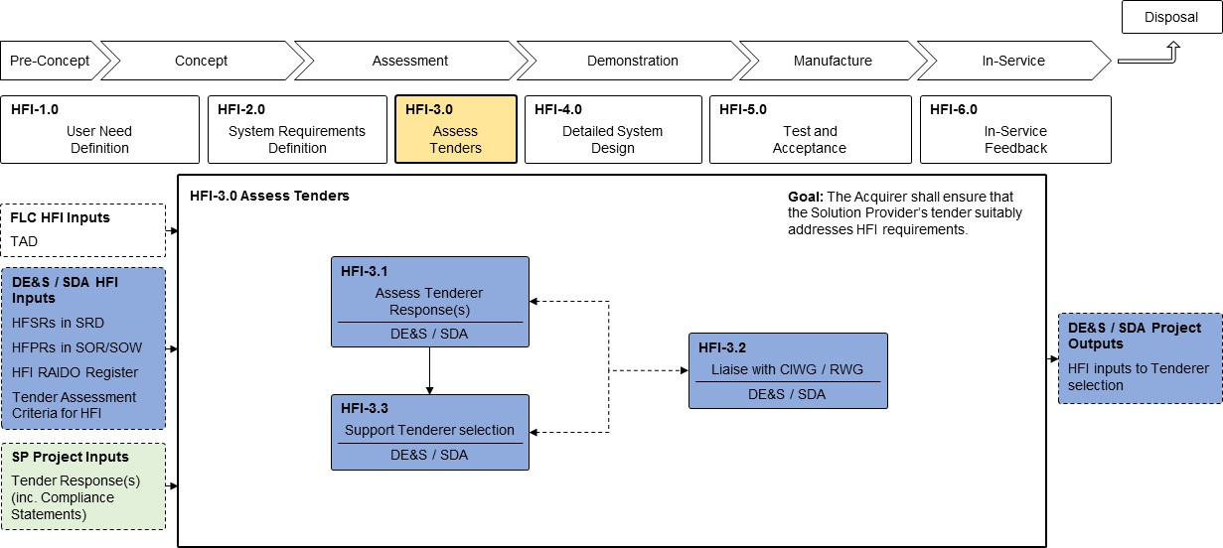

*Figure 6: HFI-3.0 Assess Tenders*

* 1. In response to the ITT, the Tenderer must generate an HFI Plan and any other materials required as specified in the SOR (forming the input to HFI-3.0)). These may include the assessment / justification of compliance and inputs to a variety of other documents, including the Integrated Test, Evaluation and Acceptance (ITEA) Plan. Product Descriptions are provided in HuFIMS for key HFI documents. These may be referenced directly in the contract or adapted to the project context in the form of project specific Product Descriptions or Data Item Descriptions supporting the SOR/SOW.
  2. The Tenderer’s HFI Plan shall detail all management and technical HFI activities to be conducted to meet the requirements (HFPRs and HFSRs) and address the HFI considerations identified. The minimum contents of the Tenderer’s HFIP are specified in HuFIMS in the HFIP Product Description ([HFI-PD03](https://www.kid.mod.uk/maincontent/business/hufims/downloads/pd/20210623-HFI-PD03-HFIP-SP.pdf)). The Tenderer’s HFIP should also provide details of any supply chain HFI activities and how these will be conducted and managed. The focus of the Tenderer’s HFIP should be on management activities. Technical activities covering all five domains shall be included, albeit at a relatively high level of detail. Technical details of some of the HFI domains may be included in other engineering plans, as appropriate: e.g. Safety Plan, Training Plan, Logistic Support Plan. The exception is the HFE domain, where a comprehensive list of activities with detailed descriptions of each shall be provided. Methods, tools and techniques to be applied shall be identified with justifications for their selection provided. In addition, a schedule of HFE activities, mapped against key project milestones (e.g. Preliminary Design Review (PDR), Critical Design Review (CDR), Factory Acceptance Test (FAT), System Acceptance Test (SAT)) shall be provided). In programmes with a significant Human Factors Engineering activity, it may be appropriate to provide a Human Engineering Porgramme Plan (HEPP) in addition or annexed to the HFI Plan.

### HFI-3.1: Assess Tenderer Response(s)

* 1. The HFIF(PT) shall scrutinise the HFI Plan and all other HFI-related documents submitted by the tenderer(s), including their statements of compliance against HFSRs. The HFIF(PT) shall assess these documents against the following criteria:
     1. compliance with the HFI Plan Product Description in HuFIMS ([HFI-PD03](https://www.kid.mod.uk/maincontent/business/hufims/downloads/pd/20210623-HFI-PD03-HFIP-SP.pdf)).
     2. the extent to which the HFPRs contained within the SOR have been addressed.
     3. the extent to which the HFI Plan addresses the identified HFI Considerations.
     4. the extent to which the HFI Plan is integrated with other project plans.
     5. the extent to which the tenderer is claiming compliance with the HFSRs.
  2. Within the assessment process the HFIF(PT) may also be responsible for conducting design analysis or contracting an independent 3rd party such as the ITS HFI Team, Dstl or an external contractor to analyse elements of the design, in order to ensure that the levels of compliance claimed by the Tenderer are achievable within the constraints of the proposed design. This may be particularly important when assessing COTS/MOTS equipment, where the opportunity for design change is limited and where there may be opportunity to test real equipment as part of the evaluation.

### HFI-3.2: Liaise with CIWG/RWG

* 1. The tender assessment process is likely to involve the identification of a range of issues and concerns with the bids from the tenderers. These may include a combination of requirements and/or process non-compliance. Understanding the impact of any non- compliance and the plans in place to address any areas of non-compliance, will be critical to ensuring the appropriate down-selection of tenderers.
  2. Any requirements trades that are considered need to be assessed for impact from all perspectives, including HFI, to ensure that the capability implications of requirements trades are fully understood. These trades and issues must be presented to the Requirements Working Group (RWG) and the Capability Integration Working Group (CIWG) for decisions to be made on how requirements trades may be handled.

### HFI-3.3: Support Tenderer Selection

* 1. The HFIF(PT) shall ensure that considerations arising from a Tenderer’s proposed HFI management and technical activities, and level of HFI competence, are assessed in accordance with the specified assessment criteria (HFI-2.10).
  2. Although the HFIF(PT) may not be directly involved in the contract negotiations, during this phase of acquisition the HFIF(PT) and the associated team will need to be ready to respond to requirement clarifications and potential changes as they arise. Changes may come in the form of requirements trades or changes to the process and timescales detailed within the tender response.

## HFI-4.0: Detailed System Design

* 1. The primary goal of the Detailed System Design stage is to ensure that all HFI requirements are addressed and that HFI considerations are managed and mitigated through the system design process. The system design process is principally run by the Solution Provider and assured by the Acquirer.
  2. The Detailed System Design stage (HFI-4.0) consists of 17 core activities as shown in

### Figure 7.

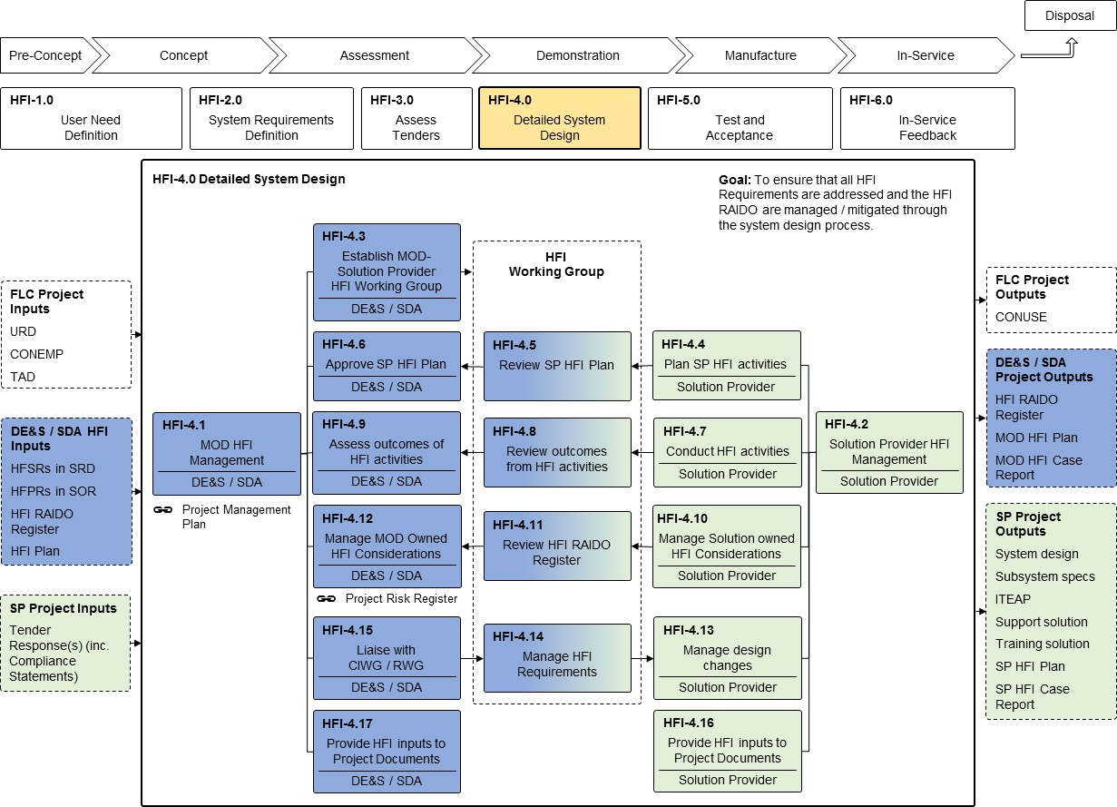

*Figure 7: HFI-4.0 Detailed System Design*

### HFI-4.1: MOD HFI Management

* 1. During the Demonstration Phase, much of the HFI work will transition from the MOD to the Solution Provider. The HFIF(PT) shall oversee the Solution Provider HFI design activities and approve outputs/deliverables.
  2. The HFIF(PT) is responsible for building links between the MOD and Solution Provider HFI communities, in order to ensure the integration of their respective HFI activities. Once under contract a number of activities fall jointly between the MOD and Solution Provider.

### HFI-4.2: Solution Provider HFI Management

* 1. The Solution Provider’s HFI Manager shall manage the system and sub-system HFI design activities. The HFI Manager is responsible for the day-to-day management of the Solution Provider’s HFI programme of work, completion of HFI progressive assurance activities and the management of the HFI Considerations owned by the Solution Provider.
  2. The HFI RAIDO Register is concerned with the low level, day-to-day management of the HFI considerations and is distinct from the project RAIDO (or risk register) that deals with major project risks. Only significant HFI Considerations that will impact the delivery of the programme as a whole should be raised to the project RAIDO / Risk Registers.

### HFI-4.3: Establish MOD-Solution Provider HFI Working Group

* 1. The HFIF(PT) shall ensure that an HFI Working Group is established to support systematic and iterative dialogue between MOD Stakeholders, MOD SMEs and the Solution Provider HFI staff. The HFI Working Group is distinct from the MOD HFI Steering Group (see HFI-2.3). The HFI Working Group should be established as soon as possible after contract award and continue its work at least until the MOD accepts the Solution. The HFI Working Group may continue during the In-Service and Disposal Phases depending on the contractual arrangement between the MOD and the Solution Provider (in instances where the capability is incrementally developed, there is value in maintaining the HFI Working Group albeit the frequency of meetings during these phases may be significantly reduced).
  2. The HFIF(PT) is responsible for chairing the HFI Working Group, although they may elect to nominate someone else from within the PT/DT or Solution Provider organisation. The membership of the HFI Working Group will reflect the HFI activities that are in hand and the project stage, but typically will include:
     1. HFIF(PT).
     2. MOD Stakeholders (including User representation).
     3. Solution Provider HFI Manager.
     4. Solution Provider SE representative.
     5. Solution Provider equipment engineer(s) (hardware/software) (as required for Human Machine Interface / Human Computer Interaction aspects).
     6. MOD and Solution Provider HF SMEs.
     7. MOD and Solution Provider Safety SMEs.
     8. MOD and Solution Provider Training SMEs.
     9. MOD and Solution Provider Maintenance and Support SMEs.
     10. Requirements Management representative(s).
  3. The HFI Working Group may be a separate group in its own right or may be part of another working group (e.g. Systems Engineering or Supportability), depending on the approach to working groups adopted by the project team.
  4. The main purpose of the HFI Working Group will be to oversee the management of all people-related considerations. The successful execution of the project HFI Plan and the management of the HFI Considerations will require regular monitoring, reporting and timely conduct of activities to examine, and where necessary mitigate, identified risks. The HFI Working Group will bring to the attention of stakeholders, all people-related considerations that are judged likely to affect the successful outcome of the project.
  5. The HFI Working Group is key to ensuring that HFI requirements are met. Suggested Terms of Reference for the HFI Working Group ([HFI-TR02](https://www.kid.mod.uk/maincontent/business/hufims/downloads/pd/2017111HFI-TR02_TOR-HFIWG.pdf)) are available on HuFIMS21.

21 Select: Resources / HFI Process Products / HFI-TR02.

* 1. The HFIF(PT) shall ensure that HFI Working Group meetings are conducted at regular intervals appropriate to the size and complexity of the project. The HFIF(PT), or nominated representative, shall convene and chair the HFI Working Group, and ensure that minutes are produced and actions arising dealt with in a timely manner. The HFIF(PT) shall liaise with the Solution Provider HFI Manager to ensure that appropriate representation from MOD, the Solution Provider organisation and any sub-contractors attend the meeting. The HFIF(PT) shall ensure that key decisions arising from the HFIWG are recorded within the HFIWG minutes and reflected in the HFI Log.
  2. The HFI Working Group will review the HFI RAIDO Register and ensure that any significant HFI risks are flowed up to the Project RAIDO (or Risk Register). The HFI Working Group will update the HFI RAIDO Register and ensure that any necessary mitigation activities are agreed and initiated.

### HFI-4.4: Plan Solution Provider HFI Activities

* 1. The Solution Provider shall generate a HFI Plan to address the project requirements defined in (and derived from) the SRD and SOR. Unless otherwise specified in the contract (or agreed with the HFIF(PT)) the contractor’s HFIP shall comply with the HFI Plan Product Description ([HFI-PD03](https://www.kid.mod.uk/maincontent/business/hufims/downloads/pd/20210623-HFI-PD03-HFIP-SP.pdf)) available in HuFIMS22.
  2. The Solution Provider is responsible for ensuring that HFI elements of the plan are integrated with other engineering and project management activities, to ensure the right HFI products are available at the right time to inform and steer decision making. As stated previously (HFI-2.9), the HFI Plan should describe the approach to both management and technical activities23.
  3. Where the Solution realisation is dependent upon sub-contractors, the Solution Provider HFI Manager shall ensure that sub-contractors are required to produce HFI Plans to address their respective HFI activities and that these lower-level plans are synchronised and integrated with the main HFI Plan and the Systems Engineering Management Plan (SEMP). The need for a solution provider’s sub-contractor to produce a HFI Plan should be determined through consideration of whether their ‘sub-system’ or contribution to the solution impact upon the human component.
  4. The management aspects of HFI are unlikely to change during the course of the Demonstration Phase. However, the schedule may be updated more frequently in line with issues and risks emerging from other HFI activities. Therefore, it may be beneficial to write the Solution Provider HFI Plan in a manner that enables the schedule to be delivered as a separate annex to the overall management plan.

### HFI-4.5: Review Solution Provider HFI Plan

* 1. The HFI Working Group shall review the Solution Provider’s HFI Plan, ensuring that it provides a systematic evolutionary design process to mitigate the identified risks and provide assurance against requirements.
  2. The first review of the Solution Provider’s HFIP should focus on the management aspects of HFI, particularly in terms of the integration of the HFI domains with the wider

22 Select: Resources / HFI Process Products / HFI-PD03.

23 A description of HFE technical activities may be included as an Annex to the HFI Plan (effectively an Human Factors Engineering Programme Plan).

Systems Engineering approach, and the breakdown of HFI activities and how they feed into the high-level schedule for the HFI programme.

* 1. Once the HFI process and activities have been established and agreed with the HFIWG, the focus of the review should shift to the detailed scheduling of the HFI programme. The HFI Plan and associated Schedule must be at a level of detail to enable the planning of user involvement and the monitoring of progress against the schedule.

### HFI-4.6: Approve Solution Provider HFI Plan

* 1. The HFIF(PT) shall approve the Solution Provider’s HFI Plan once deemed to be satisfactory. Approval of the Solution Provider’s HFIP in no way implies acceptance of the solution, rather it implies approval of the proposed process for the development of the system and the management of HFI Considerations and HFI Requirements.

### HFI-4.7: Conduct HFI Activities

* 1. This step forms the basis of much of the HFI activity within the Demonstration Phase. The Solution Provider HFI Manager shall be responsible for ensuring that HFI activities (management and technical) are conducted in accordance with the contracted Solution Provider HFI Plan and as agreed with the HFIF(PT), in order to mitigate HFI issues and risks as they arise and ensure that HFI activities feed into the detailed design in a timely fashion.
  2. Given the range and diversity of defence capability, systems and equipment, there is no single set of HFI activities that can be prescribed to achieve successful implementation of HFI for all projects. The activities needed will depend the relevant HFI requirements and the identified and emergent HFI considerations.
  3. It is important to note that a key tenet of a User-Centred Design (UCD) approach is the iteration of analysis, design and test and likely, therefore, that the results of test and evaluation activities will give rise to a need for further HF analysis and updates to design.
  4. Example activities include:
     1. Analysis Activities.
        1. Requirement Analysis and derivation of detailed (sub-system) requirements.
        2. Analysis of workplace/workspace and the working environment (noise, vibration, lighting, thermal).
        3. Task Analysis / Task Synthesis (including cognitive tasks, decision-making).
        4. Link Analysis.
        5. Allocation of Function (human-human and human-machine/autonomy).
        6. Human Performance modelling and prediction (workload, human error, situation awareness).
        7. Human Reliability Analysis.
        8. Training Needs Analysis (TNA).
        9. Analysis of maintenance space requirements.
     2. Design Activities.
        1. Application of HF standards to HCI/HMI design.
        2. Modelling, prototyping, simulation and mock-ups.
        3. Human Computer Interaction (HCI) design.
        4. Human Machine Interface (HMI) design.
        5. Workplace/workspace design (including specification of environmental factors).
        6. Training Design.
        7. Fidelity analysis of training solutions.
        8. Contribution to the development of the Support Solution.
        9. Assessment of Maintenance tasks.
        10. Organisation Design (including numbers and information flows).
        11. Contribution to the design of procedures/documentation (operating and maintenance).
     3. Test & Evaluation Activities.
        1. Assessment of compliance against contracted and derived requirements.
        2. HF experiments and trials.
        3. Manual Handling Assessment.
        4. Human performance measurement.
        5. Contribution to Safety case.
        6. Assessment of procedures/documentation.
        7. Evaluation of Training Delivery (including course content and facilities).
  5. Requirements in the SRD can be quite high-level. In addition to specific HFSRs, there may be other requirements in the SRD that have HFI implications and therefore need appropriate attention from HF SMEs. For example, a system performance requirement may be a combination of technology and people. In such cases, the system requirement will need to be decomposed in order to define the contributing human performance requirement.
  6. The Solution Provider HFI Manager shall ensure that the results of all HFI activities are made available to the HFIF(PT) and incorporated into the design and realisation of the Solution.
  7. Outputs from HFI analysis, design and test and evaluation activities should be made available to the HFI Working Group for review by stakeholders. The HFIF(PT) should act as coordinator for feedback from stakeholders in the MOD community.

### HFI-4.8: Review Outcomes from HFI Activities

* 1. The HFI Working Group shall review the outcomes of the various HFI activities undertaken by the Solution Provider. The forum provides the HFI Manager and HFIF(PT) with the opportunity to present key findings to HFI stakeholders and agree key findings and design recommendations.

### HFI-4.9: Assess Outcomes from HFI Activities

* 1. The HFIF(PT) shall ensure that HFI products and outcomes generated by the Solution Provider during conduct of the HFI Plan are assessed to determine acceptability. This includes, but is not limited to, the outcomes of any HFI analyses, design activities, and test and evaluation activities. The HFIF(PT) shall determine if the product or outcome satisfies the associated technical requirement(s) and/or mitigates the identified HFI risk.
  2. The HFIF(PT) shall work with the Solution Provider HFI Manager to identify and raise any new HFI Considerations within the HFI RAIDO Register as necessary in accordance with the output of the activities conducted.

### HFI-4.10: Manage Solution Provider Owned HFI Considerations

* 1. The Solution Provider HFI Manager shall manage the Solution Provider owned HFI Considerations captured in the RAIDO Register (see also HFI-4.12 below). Many of the HFI risks at this stage relate to human performance and/or acceptance by the end user. The Solution Provider should produce models, prototypes and/or demonstrations that can be evaluated by representative users, in order to assess the level of acceptability of the evolving design and/or to identify aspects requiring modification or further evaluation.
  2. The HFI RAIDO Register shall be maintained jointly throughout the duration of the contract. The Solution Provider HFI Manager shall ensure that Solution Provider personnel (including any relevant sub-contractor personnel) engage in regular dialogue to agree the content of the HFI RAIDO Register and achieve the outcomes for all recorded items as agreed with the HFIF(PT).

### HFI-4.11: Review HFI RAIDO Register

* 1. All existing and emerging HFI Considerations should be reviewed during the HFIWG meetings to ensure that they are being accurately recorded and tracked in the HFI RAIDO Register (or similar Project Register) and that the appropriate response strategies are being planned and actioned.
  2. On large complex programmes the HFI RAIDO Register, may include a large number of HFI Considerations. Therefore, the HFIF(PT) may choose to review the HFI RAIDO Register with the HFI Manager outside of the HFI Working Group, presenting only a subset of the key HFI Considerations at the HFI Working Group meeting.
  3. The HFI Working Group will provide a forum to discuss and agree the Solution Provider’s planned approach to addressing the HFI Considerations identified in the RAIDO Register, linking specific considerations to particular trials and development activities. The HFIF(PT) shall work with the HFI Manager to ensure that any MOD resources (e.g. people,

information, or facilities) required to support the planned activities are understood and, where appropriate, made available.

* 1. The HFIF(PT) must ensure that all stakeholders have the opportunity to contribute to the HFI RAIDO Register. Additionally, the HFIF(PT) must ensure that stakeholders are content before any risks or issues are closed, ensuring that the required evidence justifying closure is accurately referenced.

### HFI-4.12: Manage MOD-Owned HFI Considerations

* 1. During the Demonstration Phase many HFI Considerations within the HFI RAIDO Register will be owned by the Solution Provider’s HFI Manager, however, some Considerations within the Register will still be owned by the HFIF(PT).
  2. It is incumbent on the MOD to resolve any HFI Considerations under its responsibility that could impede the Solution Provider’s work.
  3. As a consequence of design decisions / trade-offs made during the project, certain design limitations will emerge that need to be acknowledged and managed by the project teams. For example, if the CIWG accepts that a system could only accommodate a limited anthropometric range of users, the selection of operators would be affected, therefore the HFIF(PT) would then have to work with the Personnel DLOD Owner to ensure that the limitation is understood and can be managed in the recruitment and selection process.

### HFI-4.13: Manage Design Changes

* 1. The Solution Provider shall manage the design changes that arise during the course of the project. Changes may be driven by the HFI team or by other engineering specialisms; therefore, there is both a proactive and reactive element to the management of design changes to ensure that the solution is optimised to the requirements set. The Solution Provider HFI team may be proactive in terms of pushing design changes forward, to enable compliance with the HF requirements set. Conversely there is also a reactive element in terms of assessing the impact of changes being driven by other engineering domains. Changes must be assessed to identify any unintended consequences, quantify any impact on compliance with HF requirements, and to inform any requirements or design trade-offs that may be required considering all aspects of the Human Component of Capability.

### HFI-4.14: Manage HFI Requirements

* 1. The HFI Working Group shall review the status of HFI requirements and work with others within the MOD and Solution Provider organisation to manage the requirements. New or amended requirements are likely to emerge during the course of the project as the capability solution is matured. The HFI Working Group provides a useful forum to identify and mature any new HFI requirements that arise during the course of the project prior to presenting them to the RWG / CIWG. Consequently, there will be a process of negotiation between MOD and the Solution Provider to decide which requirements are within or outside the scope (and price) of the original contract. If the latter, an amendment to the contract may be necessary, authorised via the contract change process.
  2. Equally any changes to requirements must be assessed for impact on the capability, and agreed through the CIWG.

### HFI-4.15: Liaise with CIWG/RWG

* 1. MOD shall liaise with CIWG and/or RWG to ensure that HFI considerations are adequately addressed and any requirements changes are agreed. This liaison will clearly be easier if the MOD and Solution Provider RMs are members of the HFI Working Group.

### HFI-4.16: Provide HFI Inputs to Project Documents

* 1. Providing a record of all HFI activities and decisions is fundamental to the acceptance and assurance of HFI on a programme.
  2. The Solution Provider shall provide HFI support to other project areas, as appropriate. There are a range of documents to which HFI must contribute, through the course of the Demonstration Phase. These will include a combination of plans, requirements documents and test reports. Typical project documents include:
     1. HFI Deliverables24 such as:
        1. the HFI Plan.
        2. the HFI Log.
        3. the HFI Case Report.
        4. the Task Analysis Report (including Task Descriptions).
        5. the HMI and HCI Style Guide.
        6. the HMI and HCI Design Specification.
        7. detailed Test Specifications.
        8. detailed Test Reports.
     2. HFI Input to the Use Case modelling / System model.
     3. HFI input to the Project Risk Register.
     4. HFI input to Hazard Identification and Hazard Analysis.
     5. HFI input to Safety Case.
     6. HFI input to ITEA Plan (see HFI-5.1 below).
     7. HFI Input to Maintenance Design.
     8. HFI input into Training Design.

### HFI-4.17: Manage HFI Inputs to Project Documents

* 1. This activity involves the ongoing management of the HFI input to project documents (and activities) outside of the immediate control of HFI. For example this may include input

24 Note: product descriptions are available in [HuFIMS](https://www.kid.mod.uk/maincontent/business/hufims/content/hufims_hfguide_product.htm) for many HFI Deliverables. Select: Resources - HFI Process Products.

into the project; Risk Register, Safety Case, Reliability & Maintainability reports, Training Needs Analysis, Verification and Validation Requirements Matrix (VVRM), ITEA Plan etc. This core activity ensures that HFI data (including RAIDO) are used effectively and efficiently across the project. Wherever possible the data should be re-used to support multiple activities.

* 1. The HFIF(PT) shall also regularly liaise with the HFI Policy team to provide assurance that HFI is being adequately addressed on the programme and signpost any issues that may affect the acceptability of the system or it’s Support Solution. The HFIF(PT) shall provide input to the development of Support Solutions Development Tool (SSDT), and GEAR Reviews in accordance with the Engineering Management Plan.

## HFI-5.0 Test and Acceptance

* 1. The primary goal of the Test and Acceptance stage is to ensure that all HFI requirements are tested and accepted (in accordance with the ITEA Plan). Typically, test and evaluation activities are conducted by the Solution Provider under close scrutiny by the MOD. The results of test and evaluation activities are then presented to the MOD for acceptance, through the agreed acceptance process detailed in the ITEA Plan.
  2. The Test and Acceptance stage (HFI-5.0) consists of 11 core activities as shown in

### Figure 8.

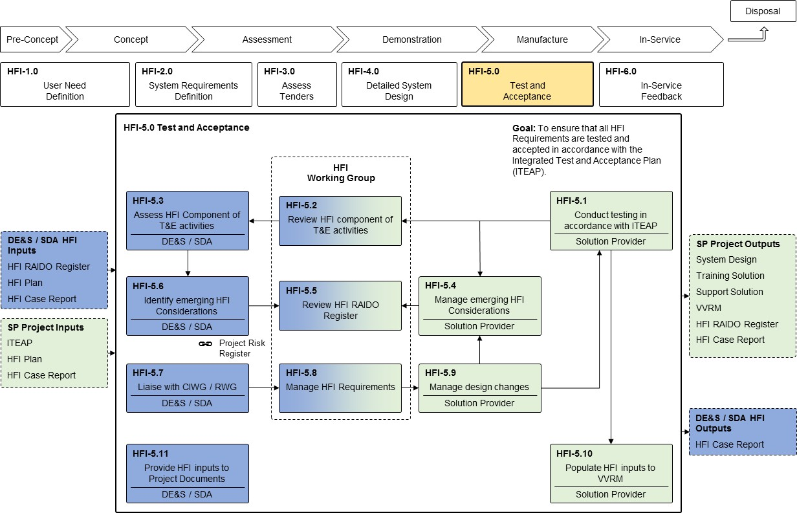

*Figure 8: HFI-5.0 Test and Acceptance*

### HFI-5.1: Conduct Testing in Accordance with the ITEA Plan

* 1. The Solution Provider’s ITEA Lead is responsible for managing and scheduling Solution Provider test and evaluation activities and for ensuring that the appropriate

engineering disciplines are engaged with ITEA activities, in order to generate the evidence required to satisfy the verification and validation criteria specified against the requirements being tested.

* 1. The Solution Provider’s HFI Manager is responsible for the planning of HFI test and evaluation activities and the generation of Detailed Test Specifications. The Solution Provider’s HFI Manager should work with the Solution Provider’s ITEA Lead to ensure that these activities are integrated into the larger ITEA Plan for the project. This includes ensuring that the HFI aspects of tests, which may be primarily focussed on non-HFI requirements (e.g. logistics, maintainability, equipment performance etc.), are appropriately addressed and integrated into test specifications. A Product Description for a Detailed Test Specification is available in HuFIMS and shall be used where no other project arrangements are in place that specify the content requirements of the Detailed Test Specifications ([HFI-PD11](https://www.kid.mod.uk/maincontent/business/hufims/downloads/pd/20190821-HFI-PD11_Detailed_Test_Specification.pdf))25.
  2. The HFIF(PT) shall review the HFI RAIDO Register with the Solution Provider’s HFI Manager prior to any test and evaluation activities to identify any HFI Considerations that can be addressed within the activity.
  3. Ultimately the MOD PT Leader is responsible for ensuring that the system being procured is accepted into service. The HFIF(PT) is responsible for:
     1. assessing test specifications to ensure that they will generate the evidence required.
     2. observing HFI test and evaluation activities to ensure that tests are conducted in accordance with the associated test plans.
     3. reviewing the test reports to ensure that they are a fair reflection of the testing conducted and the results claimed.
     4. providing the MOD PT Leader and CIWG with an understanding of the impact of any non-compliances and advising on the acceptability of the solution.

### HFI-5.2: Review HFI Component of Test & Evaluation Activities

* 1. Results of test and evaluation activities should be presented to the HFI stakeholder community at the HFI Working Group. The key findings should be agreed and any residual HFI Considerations identified and captured in the HFI RAIDO Register. HFI Considerations should be linked to both the requirement and the trials report that raised the Consideration to provide an audit trail. The HFI Working Group should review and agree how HFI Considerations identified through the test activities should be addressed.
  2. The HFI Working Group shall also review and agree any HFI Considerations in the HFI RAIDO Register that may be closed as a result of the trials.

### HFI-5.3: Assess HFI Component of Test & Evaluation Activities

* 1. Outputs of test and evaluation activities must be fully assessed for HFI compliance and the emergence of any new HFI Considerations. The HFIF(PT) must ensure that the outcomes of HFI test and evaluation activities are assessed for impact on the system as a whole. The HFIF(PT) is responsible for ensuring that the HFI RAIDO Register is updated to

25 Select: Resources - HFI Process Products - HFI-PD11.

include reference to evidence (e.g. trial reports) generated from the test and evaluation activities.

* 1. The HFIF(PT) shall be responsible for ensuring that the FLCs are aware of the outputs of the analyses and agree with the findings of the test activities and the consequent recommendations. This is normally achieved through presentation of results at the HFI Working Group, with any significant issues being raised to the programme RAIDO, RWG and CIWG, as necessary.

### HFI-5.4: Manage Emerging HFI Considerations

* 1. During the Test and Acceptance stage the HFI RAIDO Register shall be jointly managed by the HFIF(PT) and Solution Provider HFI Manager.
  2. New HFI Considerations may arise through testing that should be reported through internal management systems as well as through formal test reports. During this phase, new HFI Considerations are usually related to requirements’ non-compliances but may also be related to test procedures or other factors. Timely management of the HFI Considerations through the HFI RAIDO Register will be critical to maintaining the programme schedule.
  3. The Solution Provider HFI Manager shall identify emerging HFI Considerations as they arise and ensure that they are accurately reflected in the HFI RAIDO Register and any additional HFI activities arising as a result are reflected in the HFI schedule. The Solution Provider HFI Manager shall present the emerging HFI Considerations and proposed response plans to the HFI Working Group for endorsement.

### HFI-5.5: Review HFI RAIDO Register

* 1. During the Test & Evaluation activities the HFI Working Group shall continue to review the HFI RAIDO Register as a standard agenda item. The Solution Provider HFI Manager should seek to close Considerations within the register by providing evidence that they have been addressed and resolved.The Solution Provider HFI Manager shall present any new and emerging Considerations to the HFI Working Group for prioritisation and agreement of any reponses required.
  2. HFI Considerations within the HFI RAIDO Register shall only be closed with agreement of the HFI Working Group.

### HFI-5.6: Identify Emerging HFI Considerations

* 1. The HFIF(PT) shall review the output of Test and Acceptance activities with a view to identifying any emerging HFI Considerations and ensure that they are accurately captured within the HFI RAIDO Register.
  2. The HFIF(PT) shall ensure that any HFI Considerations that may affect the successful delivery of the project are reflected in the programme RAIDO / Risk Register.

### HFI-5.7: Liaise with CIWG/RWG

* 1. During Test and Acceptance the limited opportunity available for change increases the importance of close liaison between the HFI community and the programme management team through the RWG and the CIWG. All engineering domains will be aiming to close issues and risks within their respective elements of the project RAIDO. Design optimisation inevitably results in some level of trade between requirements and engineering domains.
  2. HFI must be represented at the CIWG / RWG to ensure that requirement trades do not negatively affect HFI requirements. If a proposed change does affect HFI, this impact must be understood and communicated to ensure that the management team is equipped with the knowledge required to make informed trade-off decisions.

### HFI-5.8: Manage HFI Requirements

* 1. Management of the HFI requirements through the course of the Test & Acceptance stage will focus principally on the collation of evidence of compliance against each of the HFI requirements. Where compliance cannot be achieved, the Solution Provider HFI Manager shall quantify and justify the non-compliance, in order to agree a way forward with HFI stakeholders, before presentation to the CIWG/RWG.

### HFI-5.9: Manage Design Changes

* 1. Throughout the course of the Test & Acceptance stage, the design of the Solution will be progressively ‘frozen’ (if not frozen already e.g. COTS), and therefore the opportunity for design change will be limited. During these activities, the system design will be held under version control and therefore a formal change control process will be required to instigate a change from the design baseline. The recording of changes from a baseline should be carried out using a change log or database. Changes will need to have a status tracking mechanism to ensure that they are actively managed through the change control process and assessments are recorded.
  2. Any proposed changes must be assessed to identify any unintended consequences, quantify any impact on compliance with the Human Factors requirements set, and to inform any requirements or design trade-offs that may be required (also see HFI-4.13).
  3. The Solution Provider HFI Manager shall ensure that any changes agreed are recorded within the HFI Log to provide an audit trail in support of the development of the HFI Case.

### HFI-5.10: Populate HFI Inputs to the VVRM

* 1. The Verification and Validation Requirements Matrix (VVRM) provides a means of recording evidence against each requirement specified in the SRD. With each test and evaluation activity conducted, the VVRM should be updated to provide linkage to the formal evidence generated.
  2. The VVRM is normally owned by the ITEA Lead within the Solution Provider organisation. The Solution Provider’s HFI Manager is responsible for providing evidence against each of the HFSRs within the VVRM to prove compliance and completion of the agreed assurance activities against each requirement.

### HFI-5.11: Manage HFI Inputs to Project Documents

* 1. The HFIF(PT) shall ensure that all necessary technical inputs are made to MOD project documentation, as required. During the Test & Acceptance stage, project documentation may include:
     1. TLMP.
     2. Hazard Log.
     3. Safety Case.
     4. Project Risk Register / RAIDO.
     5. Lessons Learned / Identified databases.
     6. HFI Case & HFI Log (MOD).
     7. HFI Plan (MOD)

## HFI-6.0: In-Service Feedback

* 1. The primary goal of the In-Service Feedback stage is to ensure that the delivered system meets the customer’s requirements through-life and that the people-related considerations associated with design changes are suitably managed. The In-Service Feedback stage is principally run by the MOD with support from the Solution Provider and Front-Line Command.
  2. The In-Service Feedback stage (HFI-6.0) consists of 4 core activities as shown in

### Figure 9.

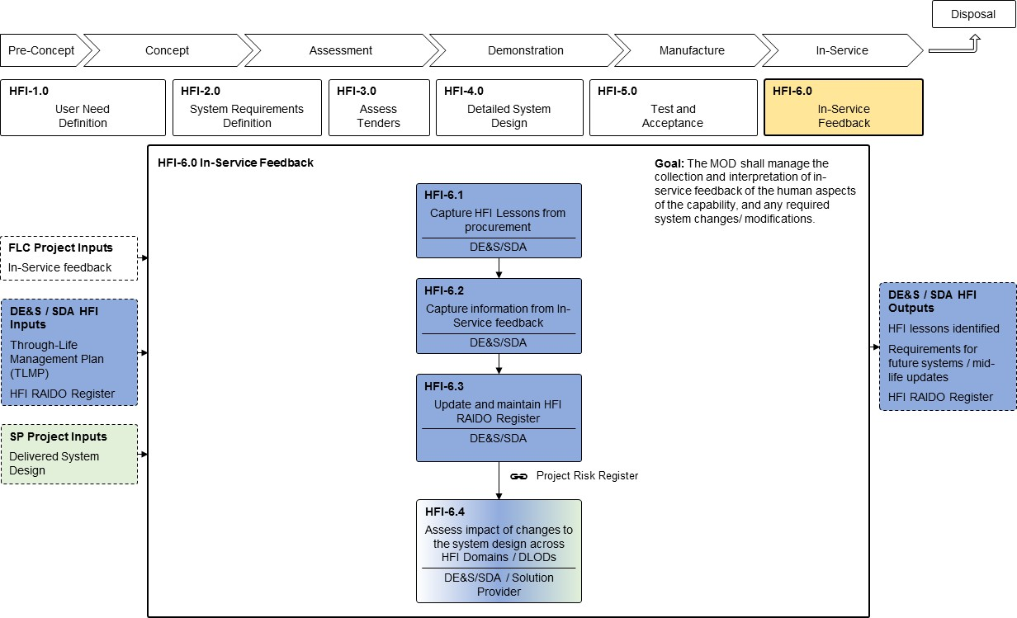

*Figure 9: HFI-6.0 In-Service Feedback*

### HFI-6.1: Capture HFI Lessons from Procurement

* 1. Prior to the project team’s ‘ramping down’, the HFI stakeholders should meet to identify lessons from the procurement activity. The focus should be on what worked well and what, with the benefit of hindsight, could have been done better. The HFI Working Group and HFI Steering Group provide a useful mechanism for capturing lessons learned.

### HFI-6.2: Capture Information from In-Service Feedback

* 1. Entry into service will inevitably be a much greater test of the capability as a whole than any of the acceptance testing that preceded the deployment of the capability. The widespread use of the capability will expose it to a much broader audience and in doing so will inevitably identify issues that slipped through the design and testing processes. It is inevitable that some issues will only become apparent when exposed to the End User in operational conditions, particularly if they differ from the orginally envisaged context of use.
  2. It is important to capture HFI lessons and issues early and throughout the In-Service Phase to ensure that the issues can be addressed in future capability iterations. This may be particularly important in large, phased procurements, such as the procurement of Naval ships, where initial in-service feedback from the first of class may inform the development of subsequent ships.
  3. In service feedback should be gathered concerning all aspects of the capability, including views from the operational, maintenance, training and support staff. Although it may not be possible to change the design of the equipment, it may be possible to further optimise the design of processes and tooling, as well as identifying improvements that may be made during mid-life updates or future spirals. For example, when considering maintenance it is important to ensure that there is an alignment *‘between work as imagined’,* ‘*work as prescribed’* and ‘*work as done’*, i.e. that there are no deviations from prescribed procedures being normalised during the maintenance of the system. Understanding, the cause of any difference and assessing and formalising any changes to procedures may be important to ensure that maintenance errors and incidents are prevented.
  4. The Defence Lessons Identified Management System (DLIMS) is the default system across Defence that is used to identify, track and manage lessons [10]. Within each Service there are also local mechanisms / processes that allow personnel to capture issues identified. These include briefings/meetings/reviews, equipment failure reports, and various safety / aviation hazard logs; however, DLIMS should be the ultimate repository for lessons captured using these local mechanisms.
  5. Information relating to the Navy Lessons Process, which is based on DLIMS, is available from the Defence Gateway Royal Navy Portal [13] and those relating to Flight Safety are recorded in the ASIMS [11].
  6. After acceptance into service, the project will normally transfer to an in-service team. At this stage the HFIF(PT) is unlikely to be a full-time role, but rather one of a number of roles that an individual may hold. The in-service team shall ensure that feedback from HFI activities HFI-6.1 and HFI-6.2 is made available to subsequent capability acquisition projects, MOD SMEs and MOD specialist functions. The feedback should be made via established Learning from Experience (LfE) processes.

### HFI-6.3: Update and Maintain HFI RAIDO Register

* 1. The identification and management of HFI considerations should not stop at the point that the system enters service; rather, issues should be continually monitored and managed through the HFI RAIDO Register.

### HFI-6.4: Assess Impact of Changes to the System Design across HFI Domains/DLODs

* 1. Through the life of a system, changes may be made to elements of the design. These

may include changes to existing equipment and systems or new capability insertions to address emerging issues / risks. Changes may vary in terms of scale and complexity. They may be required due to changes in requirements (e.g. the required operating environment; the personnel policy); or they may give rise to changes in other aspects (e.g. training, procedures, organisation). Either way, the changes should be assessed to determine the nature and magnitude of their impact, if any, across the HFI domains and DLODs. As the in- service team may not have access to an HFI SQEP it may be necessary to bring in an HFI specialist to support the assessment process.

* 1. Whenever a significant modification or upgrade is required, the acquisition procedures from earlier phases will be re-enacted on a scale appropriate to the magnitude of the undertaking, drawing heavily on stored HFI data. In particular, the HFI elements of the Safety Case will be revisited to ensure that earlier HFI considerations remain valid. This may require the change to be run through another full HFI development cycle, i.e. from requirements definition (based on capability gap), through design, testing and acceptance into service. The timescales will of course be compressed and the HFI activities tailored to the detail of the Capability update being considered.

# Tailoring the Process

## Project Types

* 1. From the point of view of MOD Investment Approvals [14], there are five main types of project (not including Business Continuity and Business Change):
     1. **Equipment**. The categorisation of an equipment project, including Technology Demonstrator Programmes (TDPs), is mainly determined by its expected procurement cost;
     2. **In-Service Support**. This is achieved within an Integrated Logistics Support Programme through the implementation of the Support system, and the provision of the services and resources as required to maintain the overall capability.
     3. **Service Provision**. For example, the provision of the Military Air Traffic Control system.
     4. **Information Communication Technology**. From small computing projects to large programmes such as the Defence Information Infrastructure Programme and its underlying networks.
     5. **Infrastructure**. Acquisition, build, refurbishment and provision of infrastructure services.
  2. In terms of equipment ‘development’, there are three main routes for the introduction of a product or Solution into service: Development Item (DI), Non-Development Item (NDI) and Off-The-Shelf (OTS).
     1. **Development Item (DI)**. A DI is a completely new item developed and designed when existing systems or product cannot meet the requirements. It is designed to meet certain performance specifications. The HFI process should be followed in full. Some tailoring of the individual activities may be required and the level of effort and attention afforded to sub-activities will depend on the size, complexity and cost of the system being acquired. Guidance on tailoring is included in the individual [process leaflets](https://www.kid.mod.uk/maincontent/business/hufims/content/hufims_hfiprocdown.htm)26.
     2. **Non-Development Item (NDI)**. An NDI is one that has already been developed and is available and capable of meeting the requirements. The research and design stages for the product will be complete and it will not be subject to a development cycle. For an NDI solution, a reduced HFI process will apply, since no design activity will be required and test and acceptance will be significantly less than for a DI solution.
     3. **Off-the-Shelf (OTS) Item**. OTS items are a subset of NDI, where the product has been developed to commercial (COTS) rather than to military standards, with minimal MOD influence on the design and may not fully meet all of the requirements. OTS items may be modified for military use (Modified/Military off the Shelf – MOTS). Design data on which to base HFI test and acceptance activities may not be available from commercial sources. If such information is required it may need to be calculated, predicted or measured on delivered products. This procurement strategy often applies to products that have undergone significant user requirements capture, analysis and

26 Select: Human Factors Integration / HFI Process / Download all HFI Process Leaflets.

user acceptance testing during the commercial design process. Although the HFI Process may not be able to influence the design, the process should be used to:

* + - 1. identify risks and concerns associated with the design.
      2. identify any necessary risk mitigation activities associated with introduction of the item.
      3. identify any required modifications to the design which may be necessary to ensure the item is fit for purpose in its military context.
      4. identify what Human Factors analyses, if any, have been applied during the design and development of the product.
  1. While there may be reduced HFI activities for NDIs and COTs/MOTs items as a result of research and design stages having been completed, additional focus may be required on the non-equipment DLODs such as personnel and training; this is due to the human component potentially having to adapt to optimise the use of the NDI/COTs/MOTs item.

## Modifications to Off-The-Shelf Equipment

* 1. The PT has a duty to ensure that equipment acquired Off The Shelf can be operated safely and effectively in a range of environments and against a range of threats. While there may be a need for some modifications to be made to such equipment prior to their acceptance into service, since they add cost and risk to what should otherwise be low-risk projects, these are to be kept to a minimum.
  2. Off-The-Shelf procurements may be considered in terms of OTS products and OTS- based Systems. There is a distinct difference between these two types of procurement.
     1. An OTS product may include a single OTS item or a defined configuration of separate OTS items sold as an integrated OTS system (the Solution Provider has already carried out the system design and its complexity is hidden from the Acquirer) where the MOD may be one of a number of purchasers.
     2. An OTS-based system on the other hand is one where the MOD seeks to develop a system based on a typically large number of OTS components in a configuration of its own design and particular requirements. Typically, each OTS component is bought separately and then integrated to form a new system configuration, never previously developed and unique to this application.
  3. The HFI process for OTS products will vary from those for OTS-based systems, this distinction should be understood when applying and tailoring the HFI Process. Although OTS products may involve little HFI activity during process stage HFI-4.0 (Detailed System Design), OTS -based systems may require significant HFI effort in this phase as although the system components are OTS the integration of these items is closer to a development item project. Further guidance on the HFI process for OTS equipment and systems is provided in HFI [Technical Guide 3.5](https://www.kid.mod.uk/maincontent/business/hufims/content/hufims_hfguide.htm).

## Tailoring within Defence Acquisition

* 1. The Knowledge in Defence (KiD) website provides generic guidance on tailoring the project governance and management roles to suit the needs of individual projects. Project

teams may provide their own supplementary instructions or guidance on how to tailor the project governance and management roles in their area.

* 1. Tailoring the (project management) lifecycle consists primarily of determining the most appropriate set of Delivery Stages to meet the particular needs of the project27. Stage boundaries must occur at the investment decision points relevant to the funding stream, for example Outline Business Case and Full Business Case.
  2. The HFI process can be tailored to suit different types of procurement. Examples of how the HFI process may be tailored to different procurement types are provided in **Figure****10**, **Figure 11**and **Figure 12**.



*Figure 10: Development Item*

**

*Figure 11: Non-Development Item*

**

*Figure 12: Off-the-Shelf Item*

## Tailoring the HFI Process

* 1. Tailoring is fundamental to the cost-effective application of HFI on a project. It is the process of identifying the range and depth of HFI activities that should be carried out and depends on the scope, size, complexity, lifecycle phase and contractual arrangements of any given project.
  2. All stages of the HFI process may be tailored. Guidance concerning the tailoring of each HFI process stage is provided in the [HFI Process Leaflets](https://www.kid.mod.uk/maincontent/business/hufims/content/hufims_hfiprocdown.htm) on HuFIMS28. The HFIF(PT) should agree the tailoring of the HFI process with the Defence Authority (HFI Policy Team) early in the procurement process and review the tailored approach periodically through the lifecycle.
  3. Before the Acquirer addresses tailoring with the Solution Provider (i.e. pre-contract), the Acquirer shall consider internally the range and depth of HFI activities that it expects to be carried out, and tailor them accordingly. This should include consideration of the areas of greatest perceived HF risk as identified by an EHFA.

27 [https://www.kid.mod.uk/maincontent/business/randa/content/principlestailoring.htm.](https://www.kid.mod.uk/maincontent/business/randa/content/principlestailoring.htm)

28 Select: Human Factors Integration / HFI Process / Download all HFI Process Leaflets

* 1. The acquisition strategy will influence the extent and scale of HFI activities that should be undertaken. The tailoring decision should be based on the answers to the following questions:
     1. How will the item be developed?
     2. Is it completely new, modified or an existing system?
     3. Will the Authority buy just the capability, a complete package or lease the system?
  2. Considerations that must be addressed in the tailoring process, include:
     1. type of project (DI, NDI or OTS).
     2. type of contract29.
     3. stage of the project / schedule constraints.
     4. time and resources available including cost limitations.
     5. availability and relevance of data.
     6. work already completed on the project.
     7. past experience and historical data on comparable projects.
  3. The HFIF(PT) is responsible for tailoring the HFI activities by considering the amount of design freedom and the availability and applicability of information in all the HFI domains. Efforts should then be concentrated on the areas where most benefit can be achieved and/or risk avoided (as identified in the preliminary HFI RAIDO Register). This can be illustrated by considering some of the main HFI activities and the difference between the two extremes of acquisiton: Development Item and Off The Shelf. With modern procurements where there will almost inevitably be a mixture of Development Items, Non-Development Items and Off The Shelf equipment, the ideal Solution will probably lie between the two extremes, with the cost and complexity of the equipment influencing any tailoring decisions.
  4. The development of the URD and SRD are assumed to be undertaken ‘in-house’ by the MOD. However, some acquisition processes may involve non-MOD contractors being employed to support the requirements development process. In this instance, the contracts for this support will need to include HFI SQEP, to ensure that the Human Component of Capability is captured, defined, tested, etc. The subsequent iterative decomposition and derivation of people-related requirements is carried out by the Solution Provider, when under contract to the MOD.
  5. Although the tailoring process needs to be considered for each HFI core activity within each HFI process stage, the majority of the core activities will be mandatory but the detail of each is tailorable. In other words, very few core activities can be tailored out completely.
  6. Further guidance on the tailoring of the HFI Process is available in the [HFI Process](https://www.kid.mod.uk/maincontent/business/hufims/content/hufims_hfiprocdown.htm) [leaflets](https://www.kid.mod.uk/maincontent/business/hufims/content/hufims_hfiprocdown.htm) on HuFIMS30.

29 See Commercial Toolkit [12].

30 Select: Human Factors Integration / HFI Process / Download all HFI Process Leaflets

# Roles and Responsibilities

**Project Team (PT) Leader**

* 1. The PT Leader shall have prime responsibility for ensuring that HFI is successfully managed in a project, and that satisfactory HFI outcomes are achieved.
  2. The PT Leader shall nominate a member of the PT to be the HFIF(PT).
  3. The PT Leader shall ensure that MOD Staff who undertake HFI management activities are provided with sufficient and suitable information and training to enable them to undertake their responsibilities31.
  4. The PT Leader shall ensure that the SRD used by the Solution Provider includes sufficient HFSRs.

## Human Factors Integration Focus

* 1. The HFI Focus is responsible for coordinating HFI activities throughout the lifecycle of the project. However, in practice there are two ‘HFI Focus’ roles performed by two people:
     1. HFI Focus within FLC/Cap community, herein referred to as HFIF(Cap).
     2. HFI Focus within the DE&S PT/DT, herein referred to as HFIF(PT).
  2. The HFIF(Cap) shall be responsible for managing the HFI activities during the Pre- Concept and early Concept stages of development, with particular emphasis on the FLC activities associated with defining the people-related User requirements for the capability. The HFIF(Cap) shall consider each of the DLODs to identify potential HFI issues and risks associated with the required Capability and the activities that will be required to address them. At this stage of procurement, the HFIF(Cap) is unlikely to be an exclusive or full-time role.
  3. The HFIF(PT) shall be responsible for the day-to-day management of HFI activities relating to the project, including both those carried out by DE&S and those carried out by others on behalf of DE&S.
  4. The HFIF(PT) shall tailor the HFI activities in accordance with the type of procurement and level of HFI risk presented. Production of plans and reports are a costly and time- consuming exercise for all concerned. Over-specifying the requirement will lead to the production of valueless reports rather than the completion of useful analysis. The HFIF(PT) must strike a balance between having sufficient tangible evidence of the Solution Provider’s work (to give confidence in their ability) and giving the Solution Provider the freedom to get on with the job.
  5. If the HFIF(PT) is not SQEP to the appropriate level, the PT Leader should engage an HFI Specialist, for example a specialist from the DE&S Internal Technical Support (ITS) HFI Team or Engineering Delivery Partner (EDP).
  6. The two HFI Focus roles will clearly need to have a close working relationship, particularly in the early phase of the project. The HFIF(PT) may well be in post for longer

31 See also KiD: [https://www.kid.mod.uk/maincontent/business/hufims/content/hufims_roles.htm.](https://www.kid.mod.uk/maincontent/business/hufims/content/hufims_roles.htm)

than the HFIF(Cap) if the former is civilian and the latter military. By the end of the Concept Phase, one would expect the HFIF(PT) to be in the ‘lead’ role.

## Requirements Management

* 1. The purpose of requirements management is to define and manage the requirements that are incorporated within the URD and SRD. Requirements management is pivotal in the delivery of the capability across the DLODs on behalf of both the Capability Sponsor and the PT Leader.
  2. However, requirements management within the MOD involves two distinct roles, each with a different scope of ownership:
     1. FLC/Cap owns the pan-DLOD Capability Requirements and is responsible for developing Capability Requirements into User Requirements.
     2. The Requirements Manager (RM) is the FLC’s representative in the DE&S project team and is responsible for translating User Requirements into System Requirements. RMs are the custodian of the ‘Golden Thread’, the unbroken, top-down linkage of requirements from Defence Policy to DLoD outputs. The RM may be supported by a Requirements Engineer (RE) from the DE&S project team32.
  3. With regard to HFI, the RM is responsible for deriving HFI requirements from the URD and incorporating them in the SRD. The SRD should have a dedicated HFI section, as appropriate.
  4. As the RM is unlikely to have detailed HFI knowledge, guidance on HFSRs should be sought from the HFIF(Cap) / HFIF(PT), as appropriate.
  5. The main roles within Requirements Management are to:
     1. manage the evolution of the URD through-life on behalf of the Capability Sponsor.
     2. manage the evolution of the SRD through-life on behalf of the PT Leader.
     3. manage the Requirements Working Group.
     4. manage any changes to the requirements that are identified as part of the design process, and crucially, to control potential requirements ‘creep’.
     5. ensure system requirements are defined and managed across the DLODs.
     6. ensure that system interoperability and compatibility requirements align to the costed user requirements to maximise cohesiveness at project boundaries.

## Capability Sponsor

* 1. The Capability Sponsor is responsible for:
     1. leading the Capability Change Planning Process.

32 See also: [https://www.kid.mod.uk/maincontent/business/randa/content/acquisitionrandaroles.htm.](https://www.aof.mod.uk/aofcontent/tactical/randa/content/acquisitionrandaroles.htm?zoom_highlight=role.%20)

* + 1. identifying the equipment and support requirements.
    2. acting as the Sponsor for new and enhanced equipment and support programmes33.

## Capability Integration Working Group

* 1. The CIWG shall ensure project integration across the DLODs to deliver the overall military capability. The CIWG provides a forum whereby integration issues, including HFI issues, may be discussed by all key stakeholders, throughout the life of the capability.
  2. The CIWG chairperson shall ensure that the Human Component of Capability is adequately captured, defined, and tested. It is recommended that the HFIF(Cap) is a member of the CIWG.
  3. The CIWG is DLOD-focussed and typically, the membership includes representatives of each of the DLODs. As stated on the [KiD website](https://www.kid.mod.uk/maincontent/business/randa/content/orgsandgroups.htm)34, there may be membership synergies within the CIWG, such that one individual may represent more than one DLOD. If this is the case, it is recommended that the differing roles and responsibilities with respect to the DLODs are made explicit within Terms of Reference and agendas.

## HFI Support Function

* 1. DE&S Engineering Group (EG) HFI Policy team shall provide information, guidance and support to MOD HFI Staff within PTs. The HFI Policy team shall work with Project Teams to agree any tailoring of the HFI Process and provide assurance that the HFI process is being applied appropriately. Although DE&S is only responsible for Equipment and Logistics (at the project level), HFI needs to be applied across all the DLODs and Through-Life. In practice, the EG HFI Policy Team is not resourced to assist beyond an initial consultation. Its main role is the management of HFI policy, standards and guidance.
  2. The Human Factors Integration Internal Technical Support team, Dstl Human Systems Group and the Engineering Delivery Partner are able to find further SQEP support to project teams, to provide the HFIF(PT) role and develop the required HFI requirements and artefacts. HFI support can be accessed by submitting a request to the Engineering Services Single Front Door35.

33 [https://www.kid.mod.uk/maincontent/business/cm/cmpg.htm.](https://www.kid.mod.uk/maincontent/business/cm/cmpg.htm)

34 Navigate to Requirements & Acceptance / Relevant Organisations and Groups

35 Contact: [Engineering Service Single Front Door.](https://apps.powerapps.com/play/e/a842d8c2-4e40-ee95-9347-8363bc51d8ab/a/ea685a07-a9d1-4474-8e95-3c29c8ee94b9?tenantId=be7760ed-5953-484b-ae95-d0a16dfa09e5&source=portal%3FskipAppMetadata%3Dfalse)

# HFI Resource Competencies

## MOD Staff HFI Competencies

* 1. Every member of MOD staff undertaking HFI activities shall be a Suitably Qualified and Experienced Person (SQEP), as defined through reference to the Human Factors Integration Functional Competence Framework [8]. This document provides a detailed description of the functional competencies for HFI.
  2. The HFIF(Cap) shall have, as a minimum, the competence of ‘Awareness’, gained through basic training and study of available materials. The target competence for the HFIF(Cap) shall be ‘Practitioner’ level36.
  3. The HFIF(PT) should hold a minimum qualification of Technical Member of the Chartered Institute of Ergonomics and Human Factors (CIEHF)37, ideally Registered Member’. Where this is not possible, the PT Leader shall appoint a SQEP, who holds a minimum of Technical Membership of the CIEHF, to support the HFIF(PT) in this role. This SQEP may be appointed from within MOD (e.g. DE&S’s Internal Technical Support HFI Team) or from outside (e.g. Engineering Delivery Partner).
  4. In addition, as the HFIF(Cap) and HFIF(PT) are HFI ‘management’ roles, awareness and experience of Systems Engineering processes and products is recommended.

## Solution Provider HFI Competencies

* 1. All HFI activities carried out by a Solution Provider shall be carried out by a SQEP, namely a professional Human Factors Engineer / Ergonomist, and/or persons with considerable experience of undertaking HFI in a Defence context. Therefore, all Solution Provider HFE personnel should hold, or be eligible to hold, at least Registered Membership of the CIEHF38.
  2. Where the Solution Provider engages sub-contractors, which is typically the case on most large projects, the Solution Provider’s SQEPs must provide adequate support to the sub-contractors and manage their activities from a HFI perspective if the sub-contractor does not have their own SQEP HF professionals.

## Ethical Approval for Research Studies and Trials

* 1. The HFI processes conducted across the CADMID or Systems Engineering lifecycle (see Figure 2) might involve research trials, experiments, tests, surveys or other forms of assessment with human participants. In such cases, the research activities shall comply with JSP 536 [15]. Annex 1A of JSP 536 provides a checklist to help teams determine whether their protocol needs to be submitted for Scientific and Ethics Review.

36 A Practitioner should have sufficient knowledge and understanding of good practice, and sufficient demonstrated experience, to be able to work on tasks with only minimal supervision. A Practitioner should maintain their knowledge and be aware of the current developments in the context in which they work. Someone with ‘Awareness’ should demonstrate a holistic understanding of the purpose and aim of the HFI process, sufficient to provide appropriate input, participation and review.

37 [https://ergonomics.org.uk/.](https://www.ergonomics.org.uk/Default.aspx)

38 It is recognised that the Solution Provider itself, as a company, might not be registered with the CIEHF (i.e. as a Registered Consultancy). However, the MOD expects that the Solution Provider’s employees will include staff individually registered with the CIEHF.

## Conduct and Behaviour

* 1. HFI research activities may need to conform to the Code of Human Research Ethics of the British Psychological Society [16] or the Code of Professional Conduct of the CIEHF [17]. In such cases, the involvement of a SQEP is essential.

# References

|  |  |
| --- | --- |
| [1] | Ministry of Defence, Defence Standard 00-251: Human Factors Integration for Defence Systems, Issue 2, 2021. |
| [2] | Ministry of Defence, [An Introduction to System Safety Management in the MOD](https://www.kid.mod.uk/maincontent/business/safety/content/sande_book.htm), Issue 4, May 2020 [Accessed 3 October 2023]. |
| [3] | International Standards Organisation, ISO 9241:210:2010: Ergonomics of Human- System Interaction - Part 210: Human-Centred Design for Interactive Systems, 2019. |
| [4] | Ministry of Defence, [Human Factors Integration Management System (HuFIMS)](https://www.kid.mod.uk/maincontent/business/hufims/content/hufims_hfguide_product.htm) [Accessed 23 August 2023]. |
| [5] | International Standards Organisation, BS ISO/IEC/IEEE 15288:2023: Systems and software engineering; System life cycle processes, 2023. |
| [6] | HFI DTC, TLCM and the People Component of Capability; Human Factors Integration Defence Technology Centre, HFIDTCPIII_T03_03, 2010. |
| [7] | Ministry of Defence, [Human Factors Integration Functional Competence Framework](https://www.kid.mod.uk/maincontent/business/hufims/content/hufims_home_train.htm), Sep 2017. Available from HuFIMS. Select: Resources/Training/HFI Competencies. [Accessed 3 Oct 2023]. |
| [8] | Ministry of Defence, [Guide to Engineering Activities and Reviews](http://webportal.wac.r.mil.uk/GEAR_Live/Controller.aspx), 23 Jun 2023. [Accessed 3 Oct 2023]. |
| [9] | Ministry of Defence, [Defence Lessons Identified Management System (DLIMS)](https://dlims.ahe.r.mil.uk/webpages/parentview.aspx), AIS [Accessed 3 Oct 2023]. |
| [10] | UK Government, [Reporting air safety concerns](https://www.gov.uk/government/collections/reporting-air-safety-concerns) [Accessed 3 Oct 2023]. |
| [11] | Ministry of Defence, [MOD Commercial Toolkit](https://www.kid.mod.uk/maincontent/business/commercial/index.htm), 1 Oct 2023 [Accessed 3 Oct 2023]. |
| [12] | Ministry of Defence, Defence Gateway Royal Navy Portal, [RNTM 03-017/18: The](https://navy.defencegateway.mod.uk/_layouts/15/osssearchresults.aspx?u=https%3A%2F%2Fnavy%2Edefencegateway%2Emod%2Euk&k=RNTM%20289%2F16&k=RNTM%2003-017%2F18) [Maritime Lessons Process](https://navy.defencegateway.mod.uk/_layouts/15/osssearchresults.aspx?u=https%3A%2F%2Fnavy%2Edefencegateway%2Emod%2Euk&k=RNTM%20289%2F16&k=RNTM%2003-017%2F18), 18 May 2018 [Accessed 3 Oct 2023]. |
| [13] | Ministry of Defence, Joint Service Publication 655: [Defence Investment Approvals](https://modgovuk.sharepoint.com/sites/defnet/HOCS/Pages/JSP-655-Defence-Investment-Approvals.aspx), Version 3.0, April 2022 [Accessed 3 Oct 2023]. |
| [14] | Ministry of Defence, Joint Service Publication 536: [Ministry of Defence Policy for](https://modgovuk.sharepoint.com/sites/defnet/JFC/Pages/JSP-536.aspx) [Research Involving Human Participants](https://modgovuk.sharepoint.com/sites/defnet/JFC/Pages/JSP-536.aspx), Version 3.5, Jan 2024. |
| [15] | British Psychological Society, [BPS Code of Human Research Ethics](https://www.bps.org.uk/sites/www.bps.org.uk/files/Policy/Policy%20-%20Files/BPS%20Code%20of%20Human%20Research%20Ethics.pdf), April 2021. [Accessed 3 Oct 2023]. |
| [16] | Chartered Institute of Ergonomics and Human Factors, ['Chartered Institute of](https://ergonomics.org.uk/advice/code-of-conduct.html) [Ergonomics and Human Factors Code of Professional Conduct](https://ergonomics.org.uk/advice/code-of-conduct.html), 18 August 2021. [Accessed 3 Oct 2023]. |

|  |  |
| --- | --- |
| [17] | Ministry of Defence, [How Defence Works](https://assets.publishing.service.gov.uk/government/uploads/system/uploads/attachment_data/file/920219/20200922-How_Defence_Works_V6.0_Sep_2020.pdf), Version 6.0, Sep 2020 [Accessed 3 Oct 2023]. |
| [18] | Ministry of Defence, JSP 912: Human Factors Integration for Defence Systems, Part 1: Directive, Version 3.0, Mar 2024. |
| [19] | Ministry of Defence, Defence Standard 00-251: Human Factors Integration for Defence Systems, Version 2, 2021. |

# Acronyms and Abbreviations

|  |  |
| --- | --- |
| **Abbreviation** | **Description** |
| CADMID | Concept, Assessment, Demonstration, Manufacture, In-service, Disposal |
| Cap | Capability |
| CBM(L) | Command and Battlespace Management (Land) |
| CDR | Critical Design Review |
| CIEHF | Chartered Institute of Ergonomics and Human Factors |
| CIWG | Capability Integration Working Group |
| CONEMP | Concept of Employment |
| CONUSE | Concept of Use |
| COTS | Commercial-Off-The-Shelf |
| DE&S | Defence Equipment and Support |
| DI | Development Item |
| DLIMS | Defence Lessons Identified Management System |
| DLOD | Defence Line of Development(s) |
| DRACAS | Defect Recording Analysis and Corrective Action System |
| Dstl | Defence Science and Technology Laboratory |
| ECA | Early Comparability Analysis |
| EDP | Engineering Delivery Partner |
| EG | Engineering Group |
| EHFA | Early Human Factors Analysis |
| FBC | Full Business Case |
| FIST | Future Integrated Soldier Technology |
| FLC | Front Line Command |
| GEAR | Guide to Engineering Activities and Reviews |
| GFA | Government Furnished Assets |
| GFE | Government Furnished Equipment |
| HF | Human Factors |
| HFE | Human Factors Engineering |
| HFI | Human Factors Integration |
| HFIF(Cap) | Human Factors Integration Focus (Capability) |
| HFIF(PT) | Human Factors Integration Focus (Project Team) |
| HFR | Human Factors Requirement |
| HoC | Head of Capability |
| HSG | Human Systems Group |
| HFPR | Human Factors Process Requirement |
| HFSR | Human Factors System Requirement |
| HFUR | Human Factors User Requirement |
| HuFIMS | Human Factors Integration Management System |
| IEC | International Electrotechnical Commission |
| IMINT | Imagery Intelligence |
| ILS | Integrated Logistics Support |
| ISSA | In-Service Support Audit |
| ISD | In-Service Date |
| ISO | International Standards Organisation |
| ISR | In-Service Review |

|  |  |
| --- | --- |
| **Abbreviation** | **Description** |
| ITS | Internal Technical Support |
| ITEA | Integrated Test, Evaluation and Acceptance |
| ITT | Invitation-to-Tender |
| JSP | Joint Service Publication |
| KiD | Knowledge in Defence |
| LfE | Learning from Experience |
| LSD | Logistic Support Date |
| MAA | Manufacture Acceptance Audit |
| MOD | Ministry of Defence |
| MQA | Manufacture Quality Audit |
| MRR | Manufacturing Readiness Review |
| NDI | Non-Development Item |
| NLIMS | Navy Lessons and Incidents Management System |
| OBC | Outline Business Case |
| OTS | Off-The-Shelf |
| PDR | Preliminary Design Review |
| PIR | Project Initiation Review |
| PT | Project Team |
| RA | Retirement Audit |
| RAIDO | Risks, Assumptions, Issues, Dependencies, Opportunities |
| RM | Requirements Manager |
| RWG | Requirements Working Group |
| SBC | Strategic Business Case |
| SE | Systems Engineering |
| SFR | System Function Review |
| SIR | System Installation Review |
| SME | Subject Matter Expert |
| SOC | Strategic Outline Case |
| SOW | Statement of Work |
| SP | Solution Provider |
| SQEP | Suitably Qualified and Experienced Person |
| SRD | System Requirements Document |
| SRL | System Readiness Level |
| SRO | Senior Responsible Owner |
| SRR | System Requirements Review |
| SSUN | Single Statement of User Need |
| T3 | Train the Trainer |
| TAR | Tender Assessment Review |
| T&A | Test and Acceptance |
| T&E | Test and Evaluation |
| TG | Technical Guide |
| TLMP | Through Life Management Plan |
| TNA | Training Needs Analysis |
| TQA | Technical Quality Audit |
| UAR | User Acceptance Review |
| UCR | Urgent Capability Requirement |
| URD | User Requirements Document |

|  |  |
| --- | --- |
| **Abbreviation** | **Description** |
| URR | User Requirements Review |
| UK | United Kingdom |
| VVRM | Verification and Validation Requirements Matrix |

# Glossary

|  |  |
| --- | --- |
| **Term** | **Definition** |
| **Acquirer** | The stakeholder who acquires or procures a product or service forming all or part of the Solution from a Solution Provider. |
| **Acquisition** | How the MOD works together with industry to provide the necessary military Capability to meet the needs of our Armed Forces now and in the future. It covers:   1. The setting of requirements; 2. The selection, development and manufacture of a Solution to meet those requirements; 3. The introduction into service and support of equipment or other elements of capability through life; and 4. Its appropriate disposal. |
| **Capability** | The ability to generate an operational outcome or effect in the context of defence planning. Capability is the enduring ability to generate a desired effect. |
| **Competence (Competent)** | Generally, the ability to perform some task or accomplish something. More specifically, the state of being adequately knowledgeable and skilled to be able to perform a specific task to an agreed level or standard. This agreed level of performance can range from novice to expert. Competence, or being competent, is the measurable outcome from the application of competencies. |
| **Competency (Competencies)** | The physical and mental skills, and the underpinning knowledge and attitudinal dispositions, that enable a person to demonstrate a certain level of competence. |
| **Concept of Employment (CONEMP)** | Describes how a new capability will be employed. It is primarily written to allow the requirements for that capability to be refined prior to Main Gate and provides a key context document in support of the User Requirements Document. |
| **Concept of Use (CONUSE)** | Describes the way in which a specified capability is to be employed in a range of activities, operations or scenarios. It is derived from the CONEMP for Main Gate in order to inform and support the System Requirements Document as a capability approaches its In-Service Date. |
| **Derogation (Dispensation)** | Permission or agreement to depart from the need to comply with a stated requirement. |
| **Effectiveness** | Accuracy and completeness with which Users achieve specified goals. |
| **Efficiency** | Resources expended in relation to the accuracy and completeness with which Users achieve goals. |
| **Equipment Component** | The totality of infrastructure, equipment, hardware, software, information and material necessary to deliver the required capability. |
| **Ergonomics** | See Human Factors (synonym). |
| **Ergonomist** | One who practices the discipline of Ergonomics. |

|  |  |
| --- | --- |
| **Term** | **Definition** |
| **Full Business Case (FBC)** | The Full Business Case is the investment decision point for the  Approving Authority. It is the final approval point prior to contract award. |
| **Full Operating Capability (FOC)** | Generally, representing the total military capability which is envisaged for a project (although it may vary from one case to another). FOC will have an expected date of achievement. |
| **Human Capability** | The collective impact that people have on the capability of an enterprise. The concept includes the results of their actions, thinking and intentions as well as the demands from their physical and mental needs. It is the product of all the influences on people at any one time, and therefore it varies as influences vary over time.  The ‘whole force concept’ places human capability at the heart of MOD decision-making and makes sure that Defence outputs are delivered by the right mix of capable and motivated people now  and in the future. [18] |
| **Human-Centred Design** | An approach to interactive systems development that aims to make systems usable and useful by focusing on the users, their needs and requirements, and by applying human factors/ergonomics, and usability knowledge and techniques. This approach enhances effectiveness and efficiency, improves human well-being, user satisfaction, accessibility and sustainability; and counteracts possible adverse effects of use on human health, safety and performance (ISO 9241-210:2010). Also known as User-Centred Design. |
| **Human Factors (HF)** | A scientific discipline concerned with the understanding of interactions amongst human and other elements of a system, and the profession that applies theory, principles, data and methods to design in order to optimise human well-being and overall system performance.  Note: This is the definition used by the International Standards Organisation (ISO). |
| **Human Factors Engineering (HFE)** | One of the seven Human Factors Integration domains. HFE addresses the widest range of HFI considerations and those of most central concern to the design of equipment and military platforms. |
| **Human Factors Integration (HFI)** | A systematic process for identifying, tracking and resolving people-related issues to ensure a balanced development of both technological and human aspects of capability.  Notes:   1. It is a management process mandated by the MOD. 2. It is the process by which the Equipment and Human Components of operational capability are made to work as a unified whole to provide the required capability (as defined by achievement of objectives and the meeting of defined performance criteria). |
| **Human Factors Requirement** | Generic term for HF Process Requirements and HF System Requirements. |

|  |  |
| --- | --- |
| **Term** | **Definition** |
| **Initial Operating Capability (IOC)** | The defined military capability standard that is considered by the Senior Responsible Owner, in conjunction with the User, to be at the minimum level to be usefully deployable. IOC will have an expected date of achievement. |
| **In-Service Date (ISD)** | The ISD is the date that the minimum usefully deployable military capability standard (Initial Operating Capability) is accepted by the relevant Senior Responsible Owner and approved by the User, and thus comes into Service. |
| **Learning from Experience (LfE)** | A through-life process which aims to promote organisational learning by identifying good and bad practice on ongoing and recently completed projects. |
| **Organisation** | A group of people and facilities with an arrangement of responsibilities, authorities and relationships. |
| **Outline Business Case (OBC)** | The Outline Business Case is the key decision point for the Approving Authority. It is the principal approval point where the agreement is reached on the preferred solution and the performance cost and time envelope is set for the next stage. |
| **People-Related Consideration** | A consideration relating to the people (users and stakeholders) and their involvement in, or interaction with, a system at any time in the lifecycle of that system. Considerations may include both positive opportunities and negative threats associated with the system development and operation. They are usually categorised as Risks, Assumptions, Issues, Dependencies and Opportunities (RAIDO). |
| **Programme** | A temporary, flexible organisation structure created to co- ordinate, direct and oversee the implementation of a set of related projects and activities in order to deliver outcomes and benefits  related to the organisation’s strategic objectives. |
| **Project** | A temporary organisation, usually existing for a much shorter time than a Programme, which will deliver one or more outputs in accordance with a specific Business Case. |
| **Project Team (PT)** | The body responsible for developing the System Requirement Document, devising equipment solutions to meet that requirement, and managing the procurement and in-service support of the equipment. |
| **Requirement** | A statement of need that is to be satisfied under the contract. |
| **Risk** | A significant, unplanned, and uncertain event or situation that, should it occur, has an effect on at least one project or programme activity, or business objective. Overall, a risk is assessed by combining its probability and the magnitude of its impact(s) on objectives. A detrimental risk is often called a ‘threat’; and a beneficial risk is called an ‘opportunity’. |
| **Safety Case** | A structured argument supported by a body of evidence that provides a compelling, comprehensible and valid case that a system is safe for a given application in a given operating environment. |

|  |  |
| --- | --- |
| **Term** | **Definition** |
| **Senior Responsible Owner (SRO)** | The single individual with overall accountability for ensuring that  a programme meets its objectives and delivers the projected benefits. |
| **Single Point of Accountability (SPA)** | The person accountable for the co-ordination of all DLODs to support the delivery of a capability. The SPA identifies boundaries, critical dependencies, potential trade-offs, balance of investment issues, risk mitigation and improved processes, in order to develop and then oversee a pragmatic and agreed campaign plan for the delivery of new and enhanced Military Capability across all DLODs. |
| **Solution** | The totality of equipment and people that provides a required capability. |
| **Solution Provider** | An organisation or an individual that enters into an agreement with the Acquirer for the supply of a product or service. This may include design, manufacture, test, supply and provision of the means to achieve a capability, together with on-going through-life support. |
| **System Requirements Document (SRD)** | The structured and live definition of the optimal system requirements (including constraints), bounding the contracting and verification activities. |
| **Stakeholder** | An individual, group or organisation that has a legitimate interest in the outcome of a project. |
| **Strategic Outline Case (SOC)** | The Strategic Outline Case is the key influence point for the Approving Authority. It is the initial engagement to agree the case for change, what is in and out of scope as the programme progresses and a high-level plan for the programme. |
| **Suitably Qualified**  **and Experienced Person (SQEP)** | An individual having the necessary knowledge, training,  qualifications and experience to enable them to carry out tasks to specified performance standards. |
| **Subject Matter Expert (SME)** | A person who has extensive knowledge, skill or experience in a particular field (e.g. operations, maintenance, support, HFI, Safety) and who can provide information, advice or guidance. |
| **System** | A combination of interacting elements or component parts, including people, operating together and organised to achieve one or more stated purposes or a unified set of goals. |
| **Tailoring** | A MOD project management process whereby the scope of work (to be undertaken by the Supplier) is adjusted to consider the type of project, its stage of development, timescales, resources, etc. |
| **Target Audience Description (TAD)** | A detailed description of the physical, psychological and sociological characteristics and organisation of the types and groups of people who will operate, support, sustain and maintain the Solution, together with supporting data. |
| **Trading** | A Requirements Management process whereby the satisfaction of a particular requirement is modified in relation to another requirement. For example, an (undesirable) increase in the weight of an equipment is allowed because it is offset by, or traded against, a (more desirable) increase in performance. |

|  |  |
| --- | --- |
| **Term** | **Definition** |
| **Urgent Capability Requirement (UCR)** | A capability shortfall or emerging capability gap identified during current or imminent operations that has never been purchased before. |
| **Use Case** | A use case is a methodology used in system analysis to identify, clarify, and organise system requirements. The use case is made up of a set of possible sequences of interactions between systems and users in a particular environment and related to a particular goal. The use case should contain all system activities that have significance to the users. A use case can be thought of as a collection of possible scenarios related to a particular goal, indeed, the use case and goal are sometimes considered to be synonymous. |
| **User** | People who operate, maintain and support the required capability. |
| **User Centred Design** | See Human Centred Design. |
| **User Requirements Document (URD)** | The structured and live, capability definition of a bounded need, recorded as user requirements. |
| **Validation** | The purpose of the Validation activity is to trial the realised system within a representative environment (CONUSE), in accordance with the User Functions/Requirements, to support User Acceptance as defined within the ITEA Plan.  Definition from Guide to Engineering Activities and Review (GEAR):  <https://moodportal.ahe.r.mil.uk/GEAR/Controller.aspx>. |
| **Verification** | The purpose of the Verification activity is to support test, evaluation and acceptance of the realised system against the Contract System Requirements verification criteria, to enable progression to User Acceptance, in accordance with the ITEA Plan.  Definition from Guide to Engineering Activities and Review (GEAR):  <https://moodportal.ahe.r.mil.uk/GEAR/Controller.aspx>. |